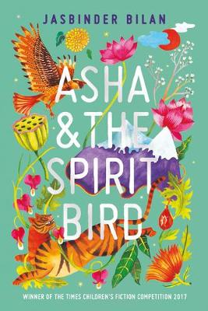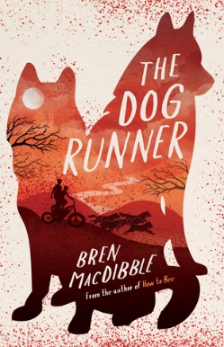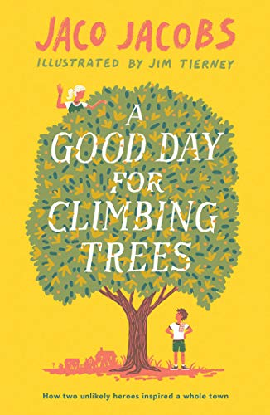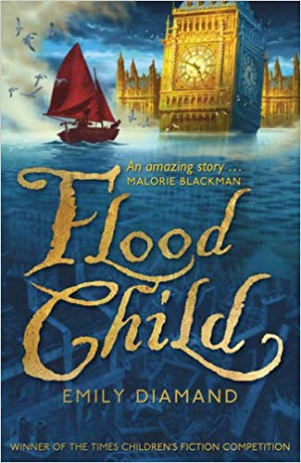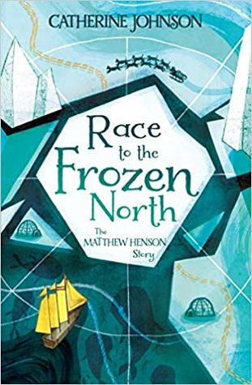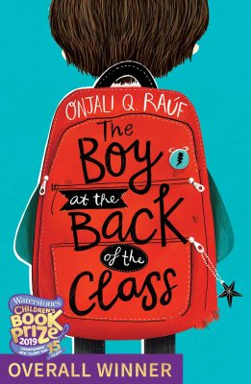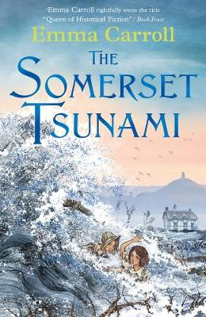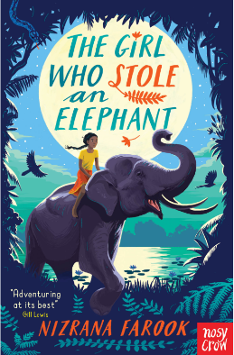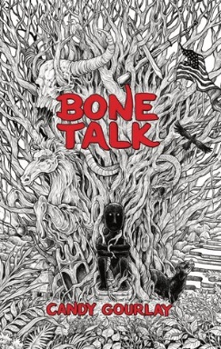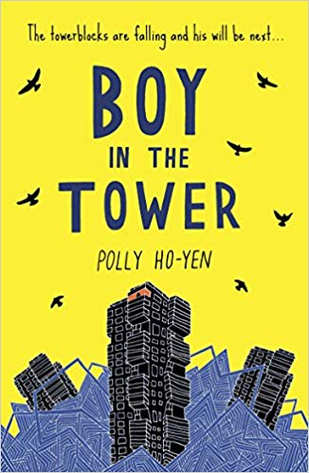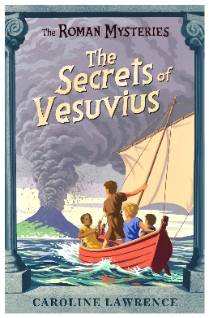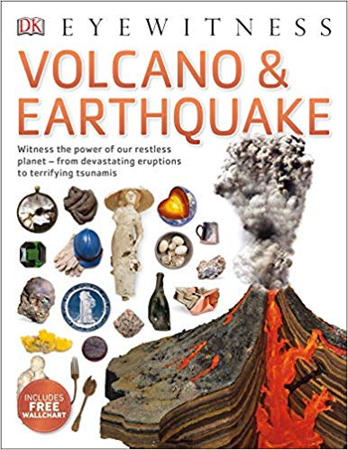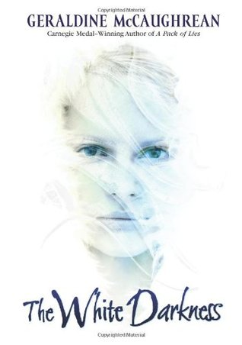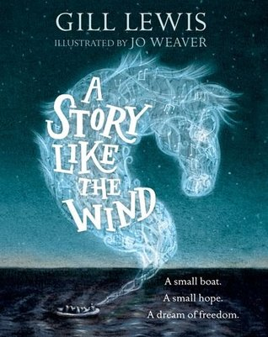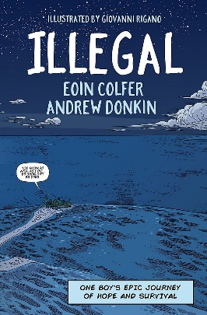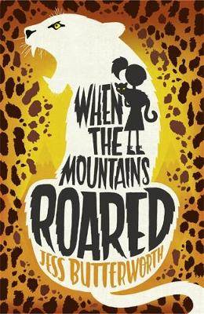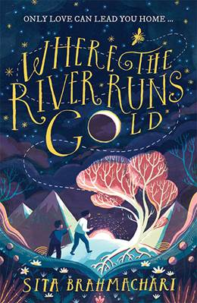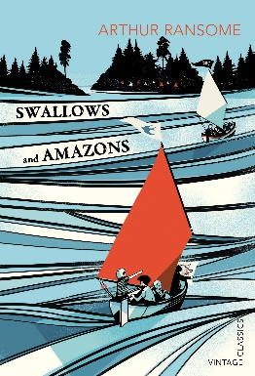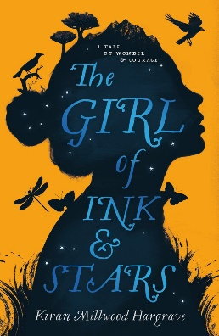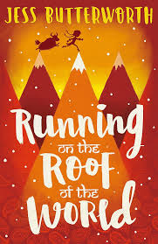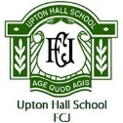

**Asia**

Asha & The Spirit Bird

By Jasbinder Bilan

**Climate Change**

The Dog Runner

By Bren MacDibble

**The Environment**

A Good Day for Climbing Trees

By Jaco Jacobs

**Flooding**

Flood Child

By Emily Diamond

**Antarctica**

Race to the Frozen North by Catherine Johnson

**Year 7 Wider Reading: Geography**

**Tsunamis**

The Somerset Tsunami

By Emma Carroll

**Asia**

The Girl Who Stole an Elephant

By Nizrana Farook

**Asia**

Bone Talk

By Candy Gourlay

**Climate Change**

Boy in the Tower

By Polly Ho-Yen

**Volcanoes**

The Secrets of Vesuvius

By Caroline Lawrence

**Volcanoes & Earthquakes**

Eyewitness Volcano & Earthquake

**Antarctica**

The White Darkness

By Geraldine McCaughrean

**Geography in the News**

A Story Like the Wind

By Gill Lewis

**Geography in the News**

Illegal

Bu Eoin Colfer & Andrew Donkin

**Climate Change**

Where the River Runs Gold

By Sita Brahmachari

**Map Skills**

Swallows and Amazons

By Arthur Ransome

**Map Skills**

The Girl of Ink and Stars

By Kiran Millwood Hargrave

**Asia**

Running on the Roof of the World

By Jess Butterworth

**Geography in the News**

The Boy at the Back of the Class

By Onjali Q. Raúf

**Asia**

When the Mountains Roared

By Jess Butterworth

**The Periodic Table**

Nature’s Building Blocks, An A-Z Guide to the Elements byJohn Emsley