
Upton Hall School FCJ
Yondr Student Phone Policy Created: March 2026
Review: September 2026 (PMc)

MOBILE PHONE POLICY

‘This policy will be implemented in a way which honours the vision that every FCJ school is a community of persons - students, staff, governors - bound together in mutual respect and ready to rely on each other in fulfilling their privileged task as educators in a Catholic school.’

Background
At Upton Hall School FCJ, we’re committed to creating a learning environment where every student can thrive. Our young people are growing up in an increasingly complex world, living their lives on and offline. This presents many exciting opportunities – but also academic, emotional and social challenges. Our goal is to promote a focused and distraction-free learning environment whilst encouraging responsible use of technology.

We believe that every student deserves the chance to experience a phone-free education and Yondr pouches provide a simple, secure way of supporting this approach across our school. This approach provides a balanced solution, ensuring young people retain possession of their phones while minimising distractions during school hours. The Pouch helps foster social interaction, improve focus on learning, and reduce stress associated with phone use, all while maintaining communication for families during travel to and from school.

Student Phone Policy & Guidelines
Our school is a phone-free community. Each student will purchase and be assigned a personal mobile phone Yondr pouch and they are responsible for bringing it to school daily and keeping it in good working condition. Phones and wearable tech will be secured in the pouch upon arrival and remain there until dismissal.

Daily Process
Upon arrival, students will:
- Turn their phone off or switch it to airplane mode.
- Place their phone and wearable tech inside their Yondr pouch and lock it in the presence of school staff.
- Keep the pouched phone with them throughout the school day, and store it in a school bag or locker.
At dismissal, students will unlock their pouch, retrieve their phone and tech, and re-close the pouch to protect the locking mechanism from damage. Pouches must be brought to and from school each day.
Note: Students arriving late or leaving early will pouch/unpouch their phones in the [Main Office]

Procedures and Sanctions
Late Arrivals/Early Dismissals
Students arriving late or leaving early must pouch/ unpouch their phones and wearable tech at the main school reception.
Forgotten Pouches
The student’s phone will be collected and securely stored in the office until the end of the day. Parents/ carers will be contacted and reminded of the procedures. If the pouch is repeatedly forgotten their pouch will be treated as lost and a replacement fee of £20.00 will be charged.

Phone Use During the School Day
If a student is found in possession of a phone outside their pouch on school site the phone will be confiscated and stored in the main office. The phone will be returned once a parent/guardian collects it. The student will also be suspended from school.

Bag searches may be conducted if teachers have concerns that a student has a mobile device on them that hasn’t been placed into their pouch.

Damaged Pouches
Any attempt to tamper with the Yondr system, including use or possession of high-strength magnets will be treated as a serious offence, potentially resulting in a replacement fee of £20.00, confiscation until a parent/guardian picks it up and suspension.

If accidental damage occurs, students must report it immediately. If damage is discovered during checks and has not been reported, it may be considered intentional.

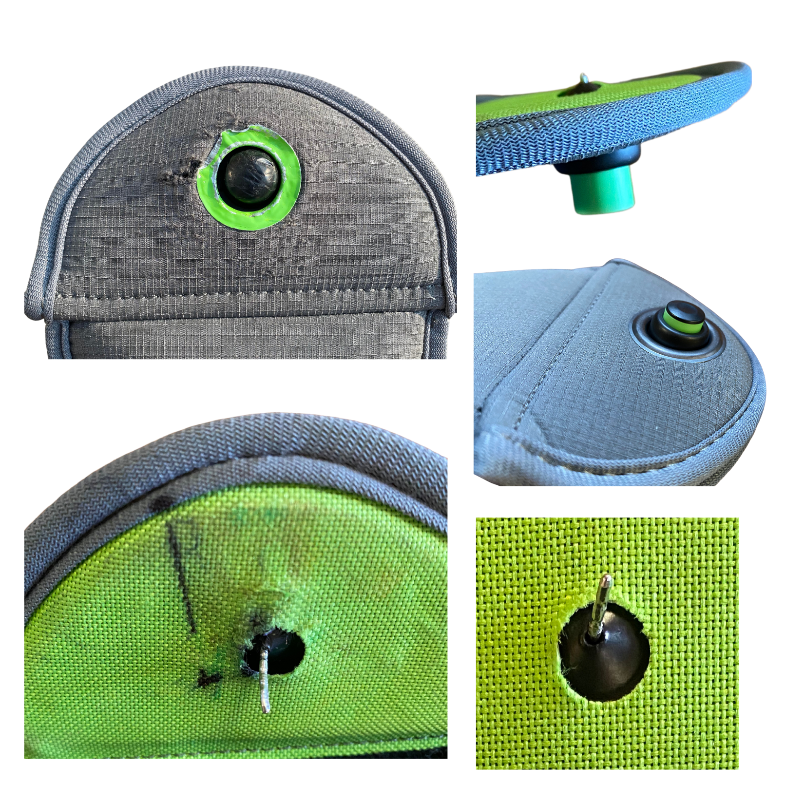
The following examples may indicate intentional damage:
- Ripped or cut fabric
- Bent or cut pin
- Signs of force to the black locking mechanism
- Pen marks inside the pouch
- Pouch opening without a station
- Scuff marks on the black ball

The pouch should not be used as a replacement for a protective case and/or screen protector on a mobile device.

Emergencies and Safeguarding
Communications During the School Day
Parents/ carers who need to contact their child during the school day should do so via the school office on 0151 677 7696. We will then pass this message onto your child.

Medical Conditions
Students who require access to their mobile devices for specific medical purposes will be provided with a medical pouch.

Emergency Procedures
In an emergency, the priority is for students to follow school safety procedures under staff guidance. Unauthorised phone use during such situations may:
- Delay emergency responses
- Spread misinformation
- Put students and staff at increased risk
- Disrupt coordinated safeguarding measures

Emergency communications will be managed through the school.
In an emergency such as a fire evacuation, one of the school leaders may bring a portable unlocking station with them if it is in grasp and safe to do so.

