Upton Hall School FCJ

Uniform and Appearance – September 2026
Uniform Policy
At Upton Hall School FCJ, we believe that our uniform is essential to the ethos of our school community as it establishes a clear sense of identity, fosters a sense of inclusive belonging, and engenders both positive behaviour and self-discipline, which in turn support teaching and learning.

Pupils should wear their uniform with pride. Visitors to the school and members of the public frequently remark on how smart Upton girls look in their uniform. Pupils should continue in this tradition by keeping their uniforms smart and clean. Pupils should ensure that their shoes are comfortable as they will do much more walking than they do in Primary School and there are many more flights of stairs to negotiate every day.

If pupils do not have the correct uniform, they may be sent home to leave non uniform items at home and return in the appropriate ones. In these circumstances, they are expected to return to school immediately. All pupils are required to wear school uniform in school and when travelling to and from school.

Pupils are allowed to wear a watch. This should not be a Smart Watch. Earrings, both clear plastic and metal (in lower and upper lobes) are not permitted. Plasters covering earrings are not permitted. If ears are to be pierced, this should be at the start of a holiday so that the earrings can be removed by the time school commences. Other jewellery such as bracelets and necklaces must not be worn. Hair, if long, must be tied back neatly. If hair is to be dyed, it must be a natural colour.

Hair bands and ribbons must be either black or green. Hats or other head coverings are not permitted. Make-up and nail varnish (including fake nails and fake eyelashes) are not allowed. This includes the excessive use of fake tan. If pupils come to school in make-up, they will be asked to remove it with wipes provided. If they choose not to use the wipes or cannot remove the makeup with the wipes, they may be sent home to remove it there and are expected to return when they have done so.

School Uniform – Years 7 – 11

BLAZER Green Blazer embroidered with school badge (compulsory)

Plain black coat (any supplier)

No other form of outer clothing is allowed

SKIRT/TROUSERS Green Regulation knee length skirt OR Trousers

BLOUSE Years 7/8 - White collared blouse to be worn with school tie (any supplier)

Rever collar blouse (no tie) to be worn in the summer term (any supplier)

Years 9-11 – Rever collar blouse (any supplier)

TIE Years 7/8 - Green/Yellow (compulsory)
JUMPER Green regulation V-necked jumper (optional)
CARDIGAN Green V-necked cardigan (optional)
SHOES Black shoes that are leather or leather look and can be polished
Heels must measure no more than 1 – 1 ½ inches

Secure fastenings are essential and shoes should not have heavy soles

Pumps are not allowed

TIGHTS Black
SOCKS Plain white ankle socks, no frills or ribbons
BAGS Plain black bag for books and other materials

All items of clothing and personal belongings must be clearly marked with the owner’s name.


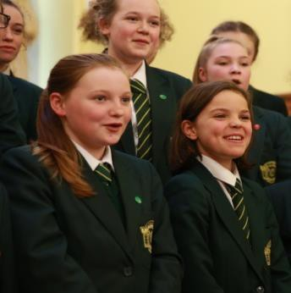


PE Kit and Equipment

POLO SHIRT Black with emerald green panel/white piping, badge embroidered in
emerald (compulsory)

SHORTS Black with emerald green panel/white piping

SKORT Black with emerald green panel/white piping

LEGGINGS Black Sports Leggings

¼ ZIP TOP Black with emerald panel/white piping, badge embroidered in emerald (optional)
HOODY Black with emerald panel/white piping, badge, embroidered in emerald

(optional)

SPORTS SOCKS 3/4 football/hockey Socks Black/Emerald/White

Black School PE Bag (with school badge) or another suitable black bag

One pair of PREDOMINANTLY WHITE Training Shoes
One pair of shin pads (a gum shield is advisable)

NO DARK SOLES WILL BE PERMITTED UNDER ANY CIRCUMSTANCES
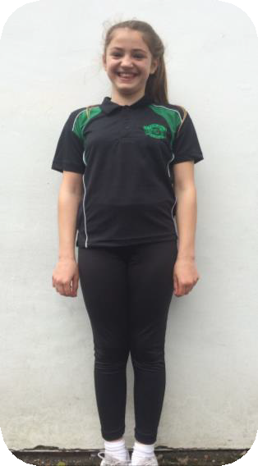
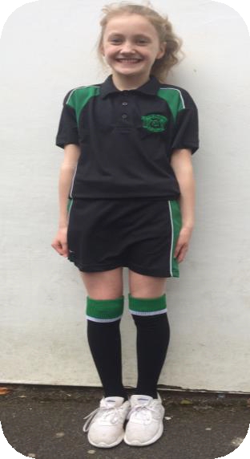

Sixth Form Dress Code 2026
Members of the Sixth Form are leaders and highly valued members of the school community. As such, you set a standard which is noted by younger members of the school. Sixth Form students are expected to achieve high standards of work and commitment. Dress is an important part of creating a business-like approach to Sixth Form life. Leisure wear can create a false impression among younger students that the Sixth Form is a leisurely experience. You are therefore requested to wear a suit that would be suitable for business.

Sixth Form life is about preparing students for the future, therefore we expect students to be professionally attired.
Our Sixth Form dress code of a smart suit includes:
- A blazer/tailored jacket (black, blue, grey, cream)
- Tailored trousers or skirt (black, blue, grey)
- Smart full length top or shirt
- Smart black shoes (please see items not permitted below)
- Sixth Form Lanyard (issued in the first half term)
- Facial jewellery is limited to earrings or one small nose stud
- Coats (outside the building only)
- Hair should be dyed natural colours

- The following items are not permitted:
- Jeans
- Shorts
- Leggings
- Short skirts (over 2 inches above the knee)
- Tops with logos
- Strappy and/or Cropped Tops
- Sweatshirts/hoodies/Heavy knit
- Trainers, white soled or canvas shoes
- Dr Marten/’biker’ style boots
- Nose rings or facial jewellery other than a small nose stud

