 | Autumn 1 | Autumn 2 | Spring 1 | Spring 2 | Summer 1 | Summer 2
Year 9 | Recap atoms, elements, compounds and mixtures from Year 7  Atomic Structure  Atomic Structure and size of atoms  Electronic structure  Isotopes and calculating relative atomic mass  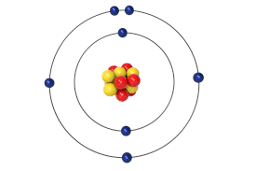  Calculating relative formula mass & percentage composition  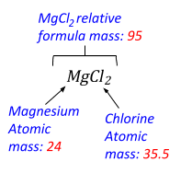 | 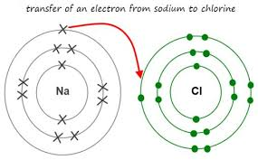  Bonding  Chemical bonds including ionic and covalent bonding  Chemical Equations  Conservation of mass  Balancing equations  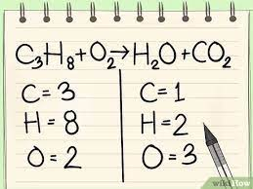 | The Periodic Table  The periodic table  Development of the periodic table  Metals and non-metals  Groups in the Periodic Table  Group 1, group 7 and group 0  Properties of transition metals  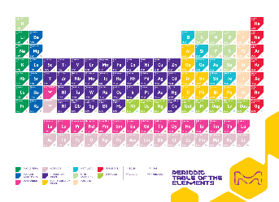  States of Matter  The three states of matter and state symbols | 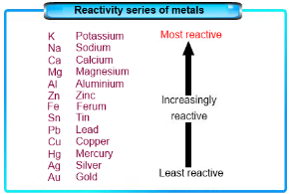  Reactivity of metals  Metal oxides  The reactivity series  Extraction of metals and reduction  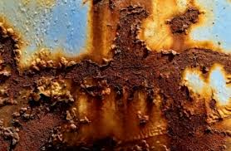  Corrosion  Corrosion and its prevention | Using the Earth's resources and sustainable development  Potable water  Waste water treatment  Alternative methods of extracting metals  Life cycle assessment  Ways of reducing the use of resources  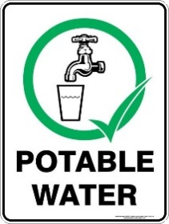 | The composition and evolution of the Earth's atmosphere  The proportions of different gases in the atmosphere  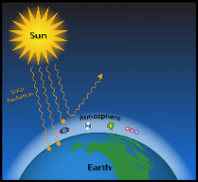  The Earth's early atmosphere & how oxygen increased and carbon dioxide decreased  Greenhouse gases & human activities which increase them  Climate change  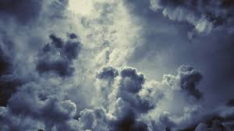  The carbon footprint and its reduction  Atmospheric pollutants

 | Autumn 1 | Autumn 2 | Spring 1 | Spring 2 | Summer 1 | Summer 2
Year 10 | Rates  Calculating rates of reactions  Collision theory and activation energy  Factors which affect the rates of chemical reactions  Catalysts  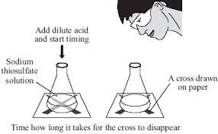 | Properties of Matter  Properties of ionic compounds, small molecules & metals  Metallic bonding  Alloys  Giant covalent structures including  diamond and graphite  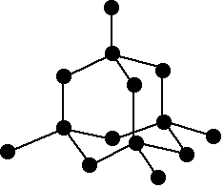  Graphene and fullerenes  Nanoparticles (separates only)  Sizes of particles and their properties  Uses of nanoparticles | Organic Chemistry  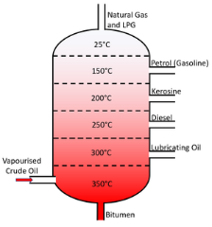  Crude oil, hydrocarbons and alkanes  Fractional distillation and petrochemicals  Properties of hydrocarbons  Cracking  Reactions of Alkenes & Alcohols (separates only)  Structure and formulae of alkenes  Reactions of alkenes  Addition polymerization | Reactions of Alkenes & Alcohols continued (separates only)  Ceramics, polymers and composites  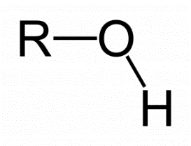  Alcohols  Carboxylic acids and esters  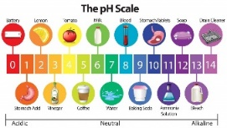  Reactions of Acids  Reactions of acids with metals  Neutralisation of acids and salt production  Soluble salts | Reactions of Acids continued  The pH scale and neutralisation  Strong and weak acids in terms of ionisation and a comparison with dilute and concentrated  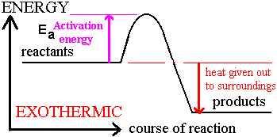  Energy Changes  Energy transfer during exothermic and endothermic reactions  Reaction Profiles  Bond enthalpy calculations | Chemical Analysis  Purity & formulations  Chromatography  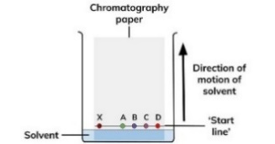  Tests for gases  Identification of ions by chemical and spectroscopic means  (separates only)  Flame tests  Testing for anions & cations  Flame emission spectroscopy
 | Autumn 1 | Autumn 2 | Spring 1 | Spring 2 | Summer 1 | Summer 2
Year 11 | Quantitative Chemistry  Uncertainty  Moles  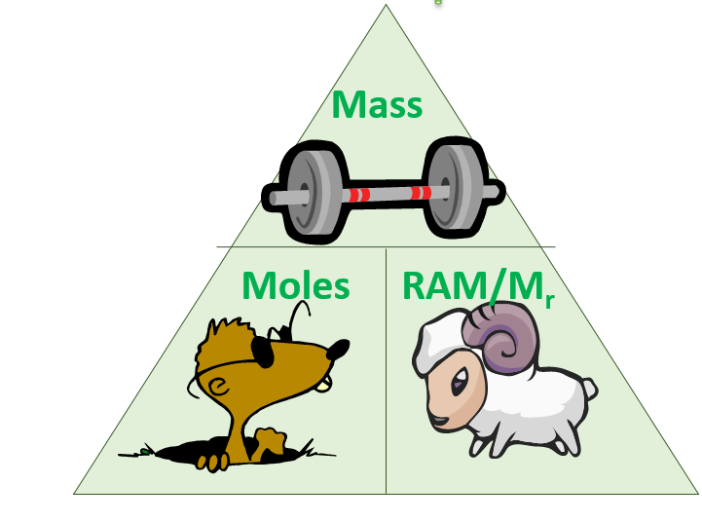  Reacting masses  Using moles to balance equations  Concentration  Titrations  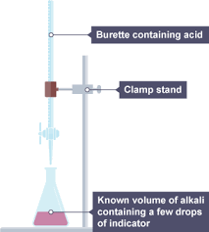  (separates only) | Yield and atom economy of chemical reactions  (separates only)  Percentage yield  Atom economy  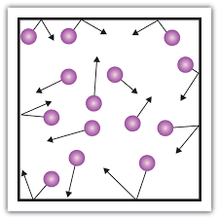  Volumes of gases  Equilibrium  The energy change of reactions  Reversible reactions  Equilibrium  The effect of changing conditions on equilibrium   |   The Haber process and NPK fertilisers (separates only)  The Haber process  Production and uses of NPK fertilisers  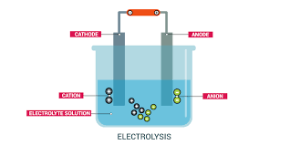  Electrolysis  Electrolysis of molten ionic compounds & aqueous solutions  Using electrolysis to extract metals  Half equations  Oxidation & Reduction | Chemical Cells & Fuel Cells (separates only)  Cells and batteries  Fuel cells  Polymers (separates only)  Condensation polymerisation  Amino acids  Naturally occurring polymers  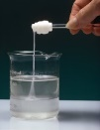 | 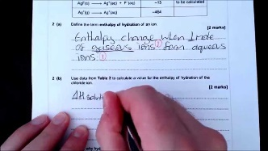 | 

