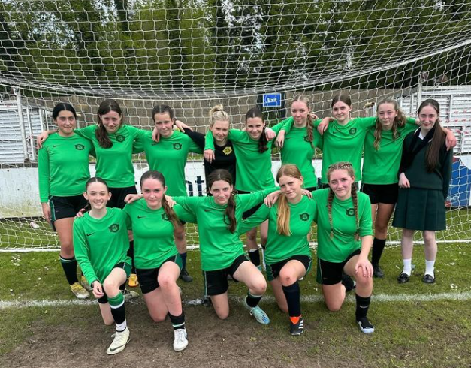
Dear Parents

As the Summer Term draws to a close and we approach summer holidays, I wanted to share some of the wide range of excellent activities and achievements in which our pupils and students are involved. This has been a short term but as you can see it has been as action packed as ever.
Football

Congratulations to our Under 15 football team who made it to the Wirral Cup final and placed second after a tight game against West Kirby.
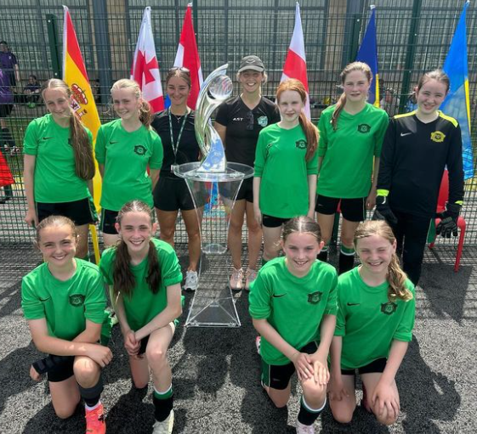

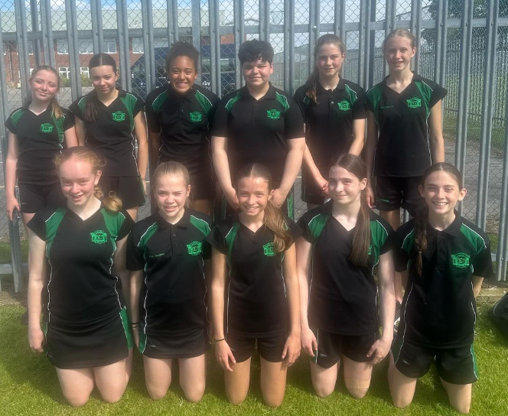

Rounders

The year 7 and 8s were lucky enough to compete in the Wirral School’s rounders tournament in the glorious sunshine. The Year 8 team made it to the finals and narrowly lost out on top spot by half a rounder. Well, done to year 7 who also made it to their semi-final!

Football Wirral School Games

The Under 13 team represented Wirral Schools in the School Games tournament placing 3rd in their tough group. We also had the amazing opportunity to have our photo took with the Women’s European Cup.

All football teams have had a fantastic season this year. Well done!

Cricket
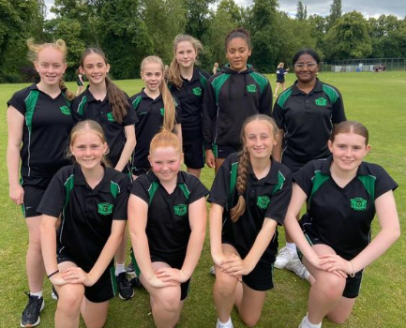
Our cricket teams have been competing in a range of competitions during the summer term. The Under 15 team made it to both the Wirral and Cheshire Cup finals and the North West finals. They are now ranked 3rd in the North West. They also made it to their semi-final in the Cheshire Cup hard ball competition. It has been great to see the growing popularity of Women and Girl’s Cricket across the county.

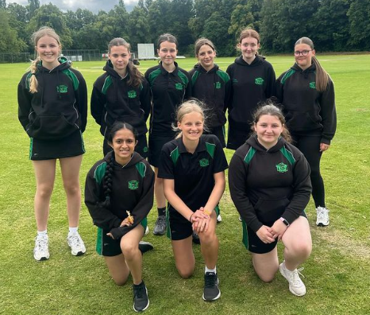

Athletics
Another busy season of athletics with most of our Wednesday evenings being at the Oval, competing in a range of competitions. It was excellent to see the number of pupils giving athletics events a go for the first time.
A special mention to our Intermediate team who qualified for the English School’s A team final but could not compete due to Culture week and work experience but came 2nd and missed out on top spot by one point!
Many of our athletics teams gained success.
- Wirral schools track event winners
- Wirral schools field events 2nd place
- Years 7-9 Wirral schools’ runners up

Under 16 Netball
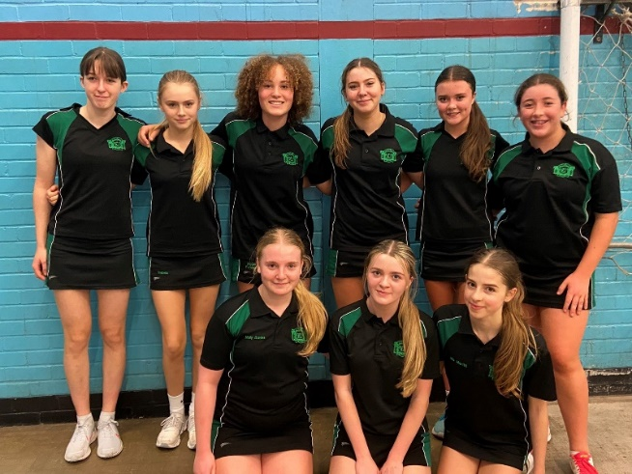

Congratulations to the under 16 netball team who travelled to Doncaster to win the Quarter final against The Hayfield School and make it to the National Semi-Finals. Due to un-foreseen circumstances, we weren’t able to make the National Finals at Loughborough but are so proud of the girls for making it that far!

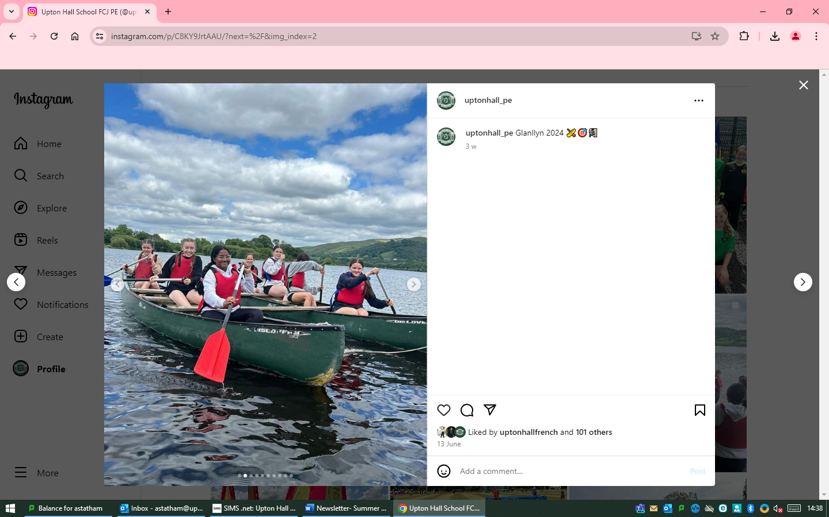
Glanllyn

What another great year at Bala Lake on our Glanllyn residential with the whole of year 8. The girls participated in a range of outdoor adventurous activities and lots of fun was had by all.

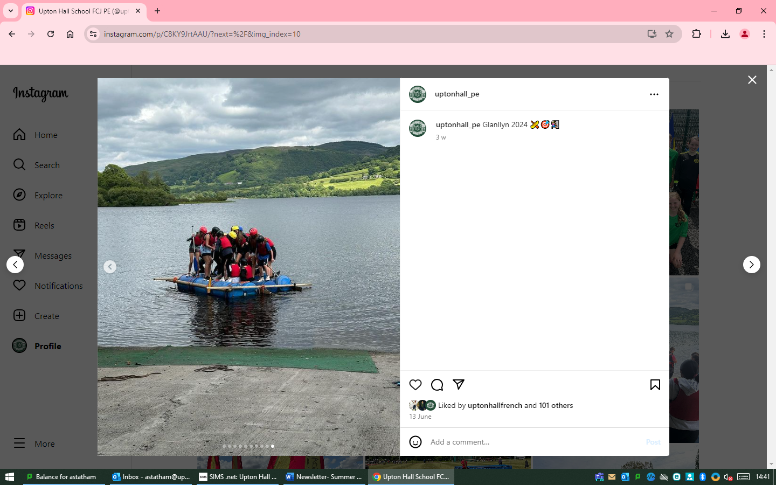
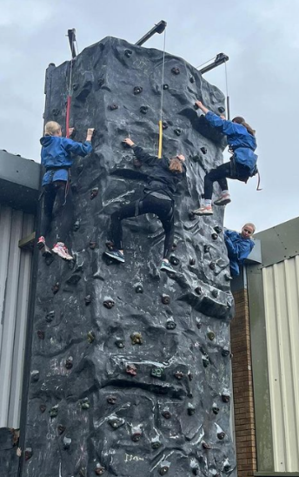

Year 9 Water Sports

During Culture week, year 9 had the opportunity to take part in Sailing on the West Kirby Marine Lake. The girls learned the basics of sailing and teamwork and had a fantastic time on the water.
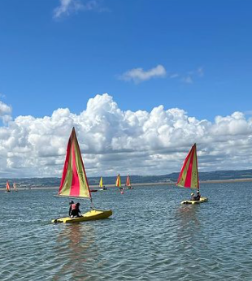

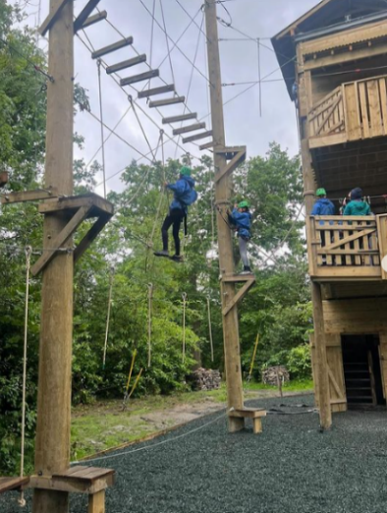

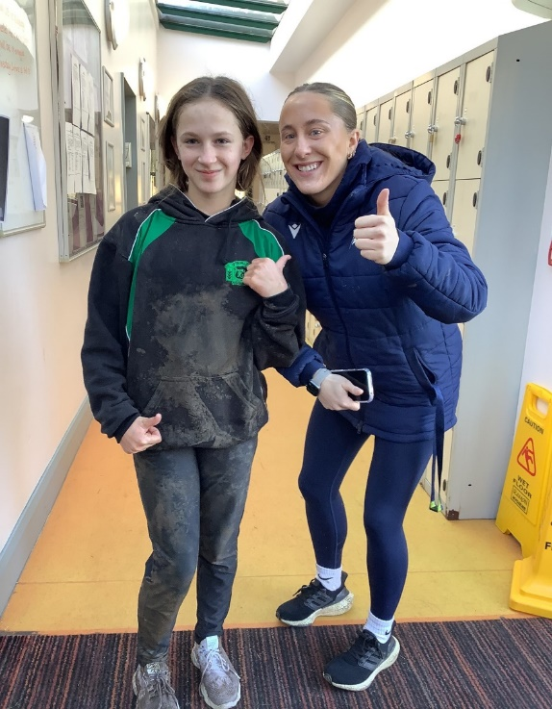

Sale Sharks Rugby
We had the opportunity to receive some coaching from professional rugby player India, from Sale Sharks. The girls absolutely loved the opportunity to get out of their comfort zones and into the mud!
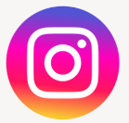
@uptonhall_pe

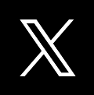
@UptonHallPE
Interform

Every year at KS3, pupils have a day of competition between forms/ houses. They compete in a number of sporting activities such as tennis, rounders, football, bench ball, cake baking, song and dance and a variety of racing events. Each year there is a winner from each form/house. This year’s winners are as follows:
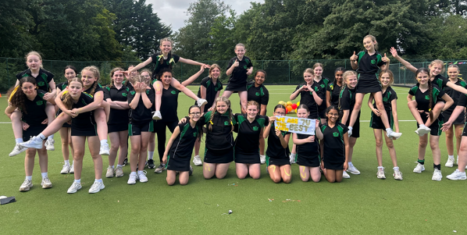
Year 9: 9H
Year 8: tbc
Year 7: 7C

Sports Day
The weather was not on our side for sports day again this year. We decided to continue with all events as best and as safe as we could so all pupils got a chance to compete. It was great to see everyone support each other and have a great day! Results are as follows:
5th Aether House
4th Air House
3rd Fire House
2nd Water House
1st Earth House
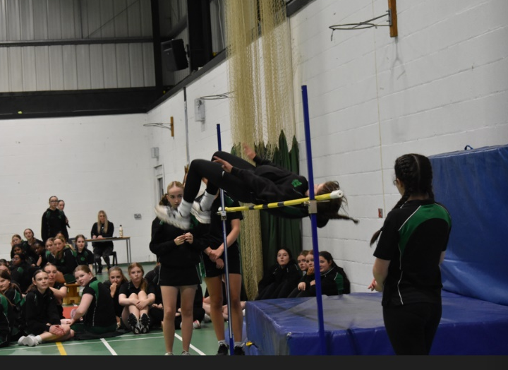
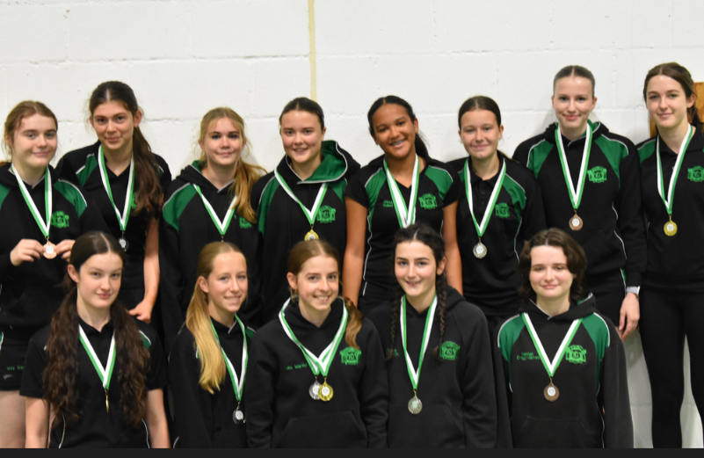

Individual success –
Poppy P – Merseyside Athletics
Holly C – Merseyside Athletics
Niamh Le’G – Merseyside Athletics
Rebecca M – Merseyside Athletics
Dior B – National Swimming finals
Lily H – National Swimming finals
Petra V – National Swimming finals
Gia H – National Swimming finals
Ellie J – National Swimming Finals
Amalie H – North West Hockey

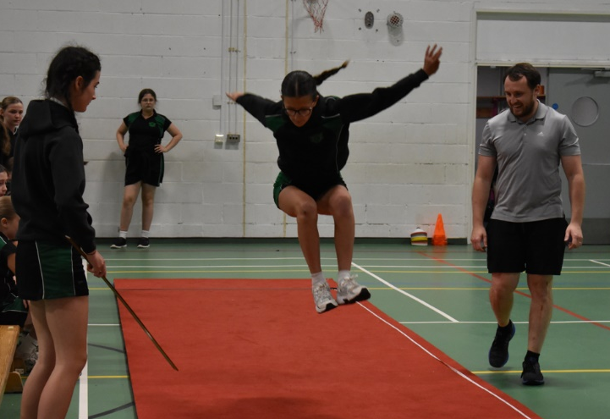
If anyone else would like to share their individual successes with us, please email pe@uptonhall.org

