Y11-12 Summer Prep
Coastal systems and landscapes
Take a look through the specification for the coastal unit:
https://www.aqa.org.uk/subjects/geography/as-and-a-level/geography-7037/subject-content/physical-geography/coastal-systems-and-landscapes
The coastal system is impacted and impacts upon processes which occur in the five oceans of our planet and the smaller seas of which they are part of. You should be aware of the different habitats and activities which are affected by and affect the coastal environment. Draw arrows to and name the locations on the Wirral of the photographed areas below – they are a mixture of coastal landforms and human uses of the coast. Can you suggest what the photos are showing i.e. the landform or human use?

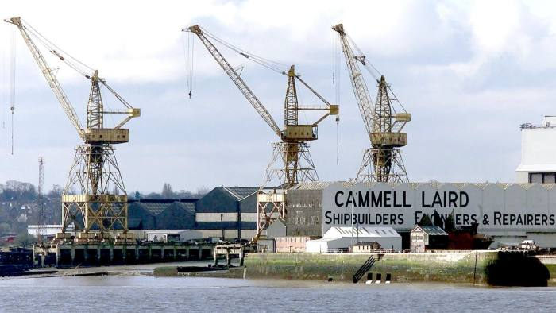
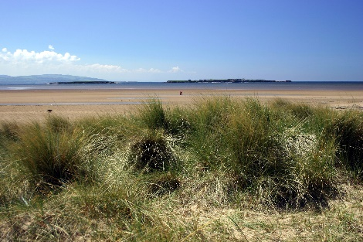

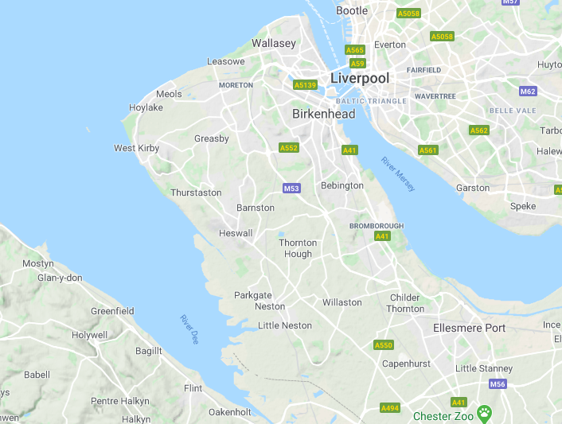

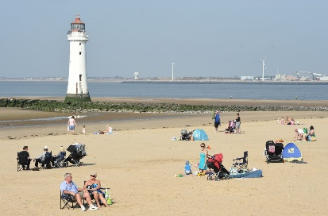

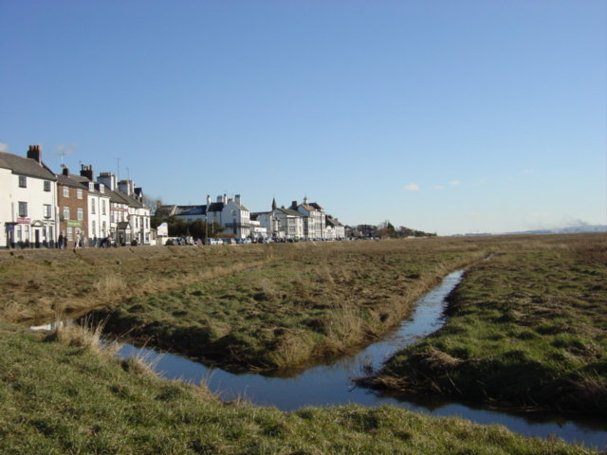
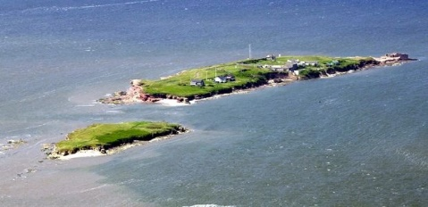

The narrow strip where the sea and land interact is shaped and influenced by both natural and human variables within a powerful system.
- Your task is to read through the fact file titled ‘Geo file: COASTAL SYSTEMS: WAVES, TIDES, SEDIMENTS, CELLS’ (https://www.solihull.tgacademy.org.uk/files/2018/08/Geog-reading-B-Coastal-systems.pdf)
- Onto a side of paper, summarise what sediment cells are and their characteristics. Questions 3a and 3b from the Focus Questions box might guide your summary of them. Can you research how many sediment cells there around England and Wales?
- Create two fact files based on the information provided – one on constructive waves and one on destructive waves. Include labelled diagrams.

Keep up-to-date with coastal geography in the news by visiting this website:
https://www.bbc.co.uk/news/topics/c6gzdpk9ggkt/coastal-erosion

