Sixth Form Pre-Induction work.
Physics.

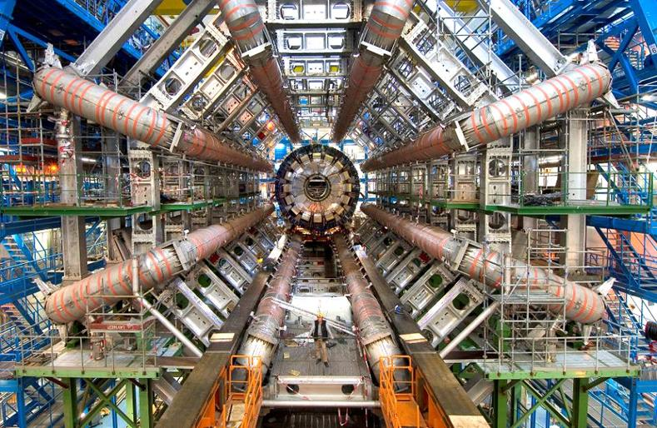

Task one: How well do you know your symbols and units?
What are the symbols and units for the following quantities?
Quantity | Symbol | Units
mass
resistance
temperature
time
weight
acceleration
area
force
current
potential difference
charge
pressure
Wavelength
displacement
velocity
Gravitational field strength
energy
power

Task two: Conversions.
Formulas use SI (Système International) units based on seven base units:
- Distance – metre (m);
- Mass – kilogram (kg);
- Time – second (s);
- Temperature – Kelvin (K);
- Current – ampere (A);
- Amount of substance – mole (mol);
- Intensity of light – candela (cd) [which you will not come across at A-level.]

It is good practice to convert your quantities into SI units. Many units may be prefixed e.g. millimetre. The table overleaf shows some common prefixes.

Prefix | Symbol | Meaning | Example
Femto | f | ⋅ 10⁻¹⁵ | 1 fm
Pico | p | ⋅ 10⁻¹² | 1 pF
Nano | n | ⋅ 10⁻⁹ | 1 nF
Micro | μ | ⋅ 10⁻⁶ | 1 μg
Milli | m | ⋅ 10⁻³ | 1 mm
Centi | c | ⋅ 10⁻² | 1 cm
Kilo | k | ⋅ 10³ | 1 km
Mega | M | ⋅ 10⁶ | 1 MΩ
Giga | G | ⋅ 10⁹ | 1 GWh
Tera | T | ⋅ 10¹² | 1 TB

Convert the following to SI units. Show all working out and remember to state your units as often units will receive a mark on the paper. REMEMBER, conversions must be done BEFORE the calculation.
15 cm
500 g
3 km
35 mV
220 nF

Task three: Standard form.
Standard form comes in very handy when using very large or very small numbers. It consists of a number between 1 and 100 multiplied by a power of 10.
7 478 000 000 000
Recap: Look at this number:
Start counting from here to get the power of 10.

There are 12 digits after the first digit, so we can write the number in standard form as:
7.478⋅ 10¹²
For fractions we count how far back the first digit is from the decimal point:
0.00000000375

There are nine places from the decimal point, so it is:
3.75 ⋅ 10⁻⁹
Convert these numbers to standard form:
86
381
45300
1 500 000 000
0.03
0.00045
0.0000000782

Task four: Rearranging equations.
Rearrange the following equations. Note which quantity is to be the subject.
Equation | Subject | Answer
V = IR | R
p = mv | v
Q = CV | C

Now try a few harder ones…
Equation | Subject | Answer
pV = nRT | V
Ep = mgΔh | Δh  (Δh is a single term)
V = -GM  r | G
λ= ws  D | D

Task five: Graph skills.
Graphs are a very important way to display your data. Here are some key points to consider about graphs…
- Always use a sharp pencil and a ruler.
- Draw the axes in, don’t just write numbers at the side of the paper.
- Label the axes with the quantity and the units
- When you plot Quantity 1 against Quantity 2, you put Quantity 2 on the horizontal axis.
- Look for the highest value in each range. You calibrate (put numbers on) your axes to the nearest convenient step above your highest value.
- Use a sensible scale – your graph should be as large as possible.
- Plot your points with crosses (+ or ×).
- Join your points with a line, but not dot-to-dot! It is possible that your results may show a curve so don’t be worried!!

Frequency (Hz) | Reactance (Ω)
500 | 100
1000 | 200
1500 | 310
2000 | 396
2500 | 420
3000 | 600
4000 | 820
5000 | 1040
Use the data below to plot a graph of Reactance against Frequency. Remember the rules!

What is the value of the reactance at a frequency of 4200 Hz?

What frequency gives a value of reactance of 700 ohms?

- Reading values off the graph is called interpolating.
- When we extend the graph, we are extrapolating.

Work out the gradient of your graph. Show on your graph how you got the gradient.
Often examiners will ask for the units of the gradient, what are the units of your gradient?

Plot the following data and join the points with a line of best fit. Note that there is an anomalous result.

Voltage (V) | Power (W)
0 | 0
2.5 | 2.0
5.0 | 4.1
7.5 | 18.4
10.0 | 31.8
12.5 | 52.1
15.0 | 72.6
17.5 | 100
20.0 | 128
Which point is the anomalous result? Show how to identify this on a graph.

How can you avoid anomalies?

Define the following words mean in relation to graphs and data?
Reliable: ______________________________________________________________________________________________________________________________________
Valid: ______________________________________________________________________________________________________________________________________
Why do we draw a line of best fit? _________________________________________________________________________________________________________________________________________________________________________________________________________
Task six:
Write a short paragraph about something that interests you in Physics.

