Key Stage 3 Curriculum Overview, from September 2021
Upton Hall School FCJ Science Department

 | Autumn Term |  | Spring Term |  | Summer Term
Year 7 | Introduction to science laboratory safety and investigation skills,  What is an independent variable?  What is a dependent variable?  What are control variables and why are they important?  How can we ensure the data we collect from science investigations is both accurate and repeatable?  Pupils will learn how to present data in both tabular and graphical form.  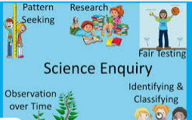  Assessment –short exam style interim assessment – marked by teacher and graded D,S,E. | Elements & compounds – pupils will be introduced to the periodic table of elements and though practical experimentation, recall the differences between elements and compounds.  Model of the atom and particle theory – pupils will research how the understanding of the structure of the atom has changed over time. Pupils will also be introduced to particle diagram to represent differences between solids, liquids and gases as well as elements and compounds.  Mixtures – pupils will investigate the differences between compounds and mixtures and how mixtures can be separated. They will also use their knowledge of particle theory to identify compounds and mixtures using particle diagrams.  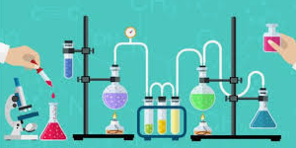  Assessment –exam style full lesson assessment – marked by teacher and graded D,S,E used to inform tracking. | Cells – pupils are introduced to the structure of animal and plants cells. This idea is developed through discovery of the adaptations of a number of specialised cells.  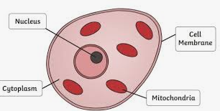  Energy – pupils will encounter several different types of energy sources and be introduced to the law of conservation of energy. They will also conduct some research into sources of renewable energy.  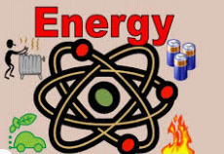  Assessment - short exam style interim assessment – marked by teacher and graded D,S,E. | Reproduction – pupils will study the structures of the male and female reproductive systems. They will also study the menstrual cycle and pregnancy.  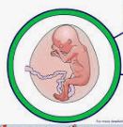  Digestion – pupils will identify the organs of the digestive systems and be introduced to the role of enzymes in digestion.  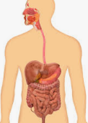  Assessment - exam style full lesson assessment – marked by teacher and graded D,S,E used to inform tracking. | Gravity & Forces - pupils will work on the knowledge from KS2 investigating different force types. Force diagrams will be used to identify force types and calculate resultant forces.  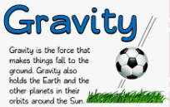  Breathing – pupils will be introduced to the structure and function of the breathing system and how we breath. Investigations into lung volumes and breathing rate will be carried out using data loggers.  Respiration – pupils will link the knowledge of breathing to respiration and recall its word equation. Investigation into factors affecting respiration rate will be conducted.  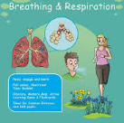  Assessment - short exam style interim assessment – marked by teacher and graded D,S,E. | Assessment – end of year examination – pupils will complete a one-hour exam style question exam encompassing all topics and skills covered throughout the year  Maths in Science – pupils review some of the data analysis and presentation skills they have covered across the year and apply these to Science based exam questions.  Science in the real world – Pupils conduct practical investigations aiming to answer so ‘real life’ scenarios e.g. Does the temperature of water affect how quickly blood travels to a shark’s nose?
Year 8 | Investigation skills recap  Pupils will review the science investigation skills mastered in year 7. This will be followed by a short assessment.  Photosynthesis – pupils will study the process of photosynthesis and adaptations of plant. They will also investigate the effect of light on the rate of photosynthesis  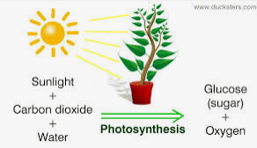  Interdependence & ecosystems – pupils will look at energy transfers through food chain and the terminology associated with this.  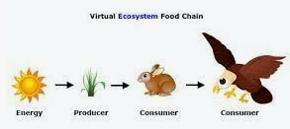  Assessment – short exam style interim assessment – marked by teacher and graded D,S,E. | Acids and alkalis – pupils will be introduced to the pH scale and identify the pH of acidic, alkali and neutral solutions. They will also investigate the concept of neutralisation and apply to everyday applications.  Chemical changes – pupils will investigate the differences between physical and chemical changes. They will also write work equation for reactions between metals & oxygen/acids/carbonates  Assessment - exam style full lesson assessment – marked by teacher and graded D,S,E used to inform tracking. | Light  Pupils will investigate how light travels and how we see and hear things.    Sound  Pupils will investigate how sound travels and how we hear things. They will also look at identify different sound types from waves.    Assessment - exam style full lesson assessment – marked by teacher and graded D,S,E used to inform tracking. | Assessment – short exam style interim assessment – marked by teacher and graded D,S,E.  Electricity – pupils will build and draw diagrams of series and parallel circuits explaining the differences in current and voltage.  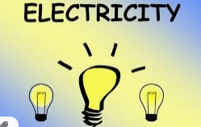  Magnetism – pupils will investigate magnetic fields and apply this to how a magnet work. They will also look at electromagnets and how they are used in our everyday lives.  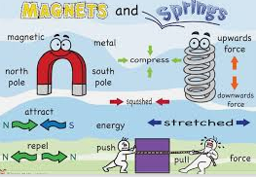 | Assessment – exam style full lesson assessment – marked by teacher and graded D,S,E used to inform tracking.  Inheritance, variation & evolution – Pupils will discover the location and function of DNA and how it can be passed on during reproduction. Pupils will look at how the environment and genes are responsible for variation and how this can lead to natural selection and consequently evolution.  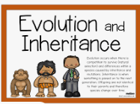  Assessment – short exam style interim assessment – marked by teacher and graded D,S,E. | Speed – use and rearrange mathematical formula to calculate speed of an object. Interpret time-distance graphs and calculate speed at given points.  Universe –pupils will design a poster for display on the solar system including information on the planets and how the moon and sun interact to create night and day, the seasons.  Earth and the atmosphere – pupils will draw on their learning from geography to identify the structure of the earth and different types of rock. They will also look at the impact and causes of global warming.  Assessment - end of year examination – pupils will complete a one hour exam style question exam encompassing all topics and skills covered throughout the year.  Maths in Science – pupils review some of the data analysis and presentation skills they have covered across the year and apply these to Science based exam questions.  Science in the real world – Pupils conduct practical investigations aiming to answer ‘real life’ scenarios e.g. Does the mass of a person affect how long a bungee rope will stretch?
KS3 Curriculum Overview: Rationale and Assessment

Why are you teaching what you are teaching when you are teaching it?
Year 7 - The KS3 Science curriculum begins in year 7 by laying the foundation for the science investigation skills that pupils need to embark on discovery and understanding of concepts through practical experimentation. has been designed to include all elements of the KS3 Science national curriculum with a particular focus on making links between the different Science disciplines to encourage students to experimental design and data analysis. The autumn term then continues with a number of Chemistry topics which allow pupils to become more familiar with lab equipment and practical investigation early in their secondary school experience. The spring term sees predominantly Biology topics being taught alongside the Physics topic ‘energy’. This allows pupils to make the link between the need for energy in biological processes and how the law of conservation of energy. The summer term continues with the Physics theme and lots of discovery through experimentation in the Forces topic. The course is then brought to a close with Biology looking at the human body and breathing and respiration.
Year 8 – This year begins with a recap and mini assessment of the science investigation skills from year 7 to remind pupils off their importance in every discipline. The autumn term begins with plant biology and ecology when we can take advantage of the school grounds and solar to conduct some learning outside the classroom. Chemistry topics follow in the second half of the summer term to allow pupils to revisit their lab skills. The spring term has a Physics theme which begins with ‘waves’ covering light and sound to allow the relevant links to be made. These topics are assessed and followed by electricity and magnetism. The summer term then begins with Biology topic ‘inheritance and evolution’ followed by Physics ‘the universe’ and Chemistry ‘the earth and atmosphere’. Although these topics are taught in the conventional way there are opportunities for independent study and research which pupils in year 8 benefit from being introduced to before embarking on GCSE course.

How do you propose to assess Science at Key Stage 3?
Assessments include exam style questions from KS3 SATS papers. Pupils will be set one weekly homework which will be either teacher, pupil or self-assessed. A short 10-15 min interim assessment will take place at the midpoint of each half term followed by a longer full lesson assessment which a range of recall, application and data analysis skills assessed. Pupils will be graded DEVELOPING, SECURE or EXCELLENT based on grade boundaries determined once date has been collected. Those scoring a DEVELOPING are invited to attend intervention and mentoring sessions from year 9 pupils.

