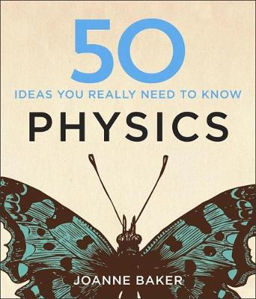
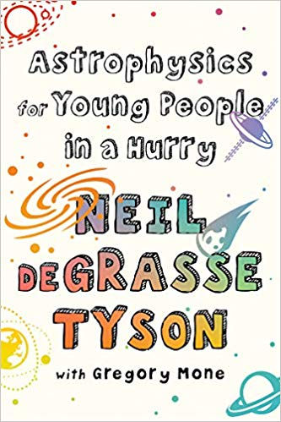
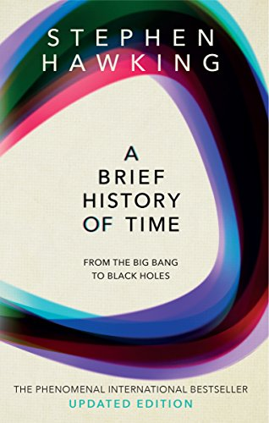
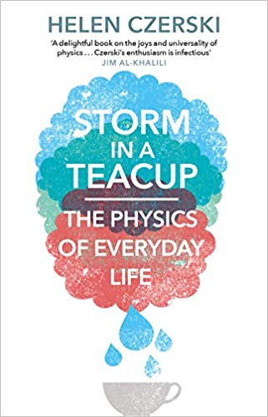
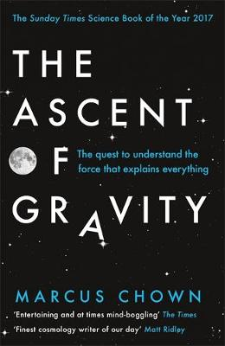
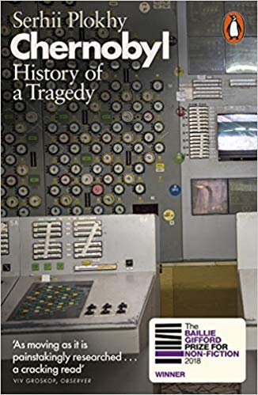
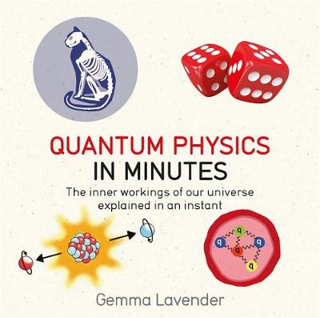
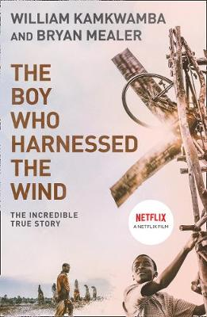
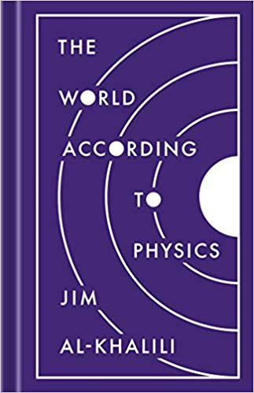
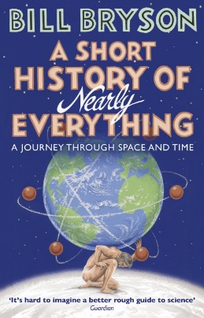
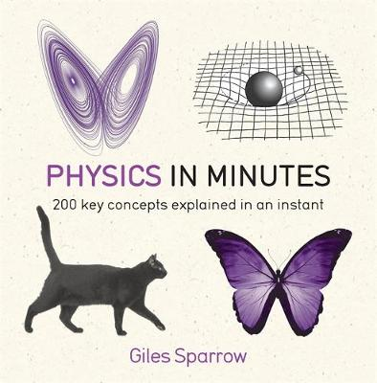
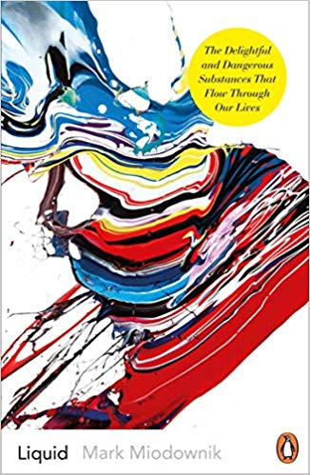
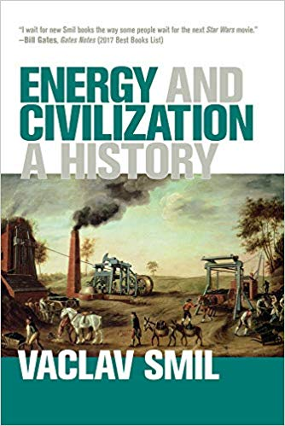
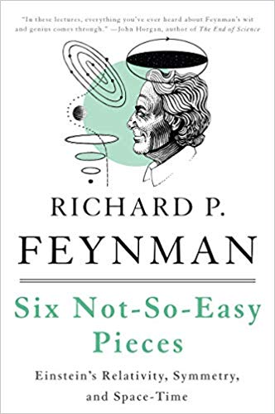
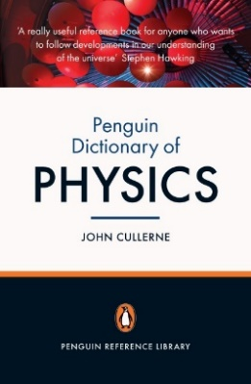
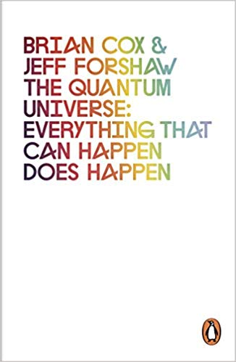
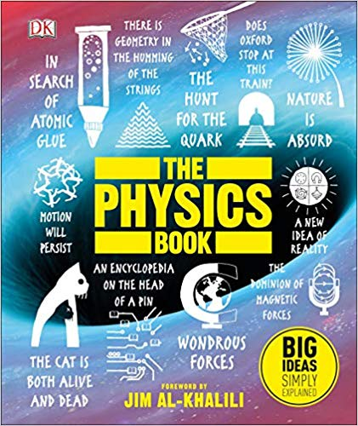
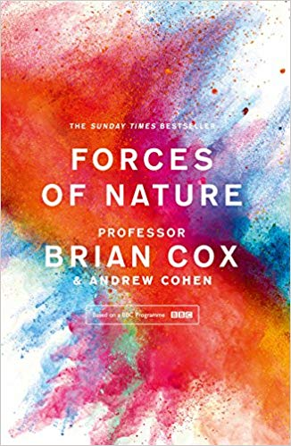
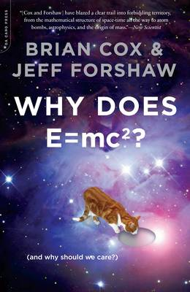
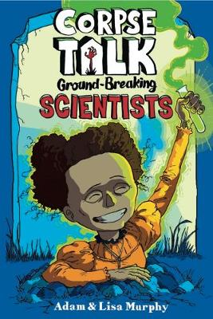

Space Physics
Astrophysics for Young People in a Hurry
By Neil DeGrasse Tyson

Waves
A Brief History of Time
By Stephen Hawking

Magnetism
Storm in a Teacup, The Physics of Everyday Life
By Helen Czerski

Forces
The Ascent of Gravity
By Marcus Chown

Nuclear Fission
50 Ideas You Really Need to Know
By Joanne Baker

Radiation
Chernobyl, History of a Tragedy
By Serhii Plokhy

Atomic Structure
Quantum Physics in Minutes
By Gemma Lavender

National and Global Energy Resources
The Boy Who Harnessed the Wind
By William Kamkwamba and Bryan Mealer

Particle Model of Matter
The World According to Physics
By Jim Al-Khalili

History of Physics
A Short History of Nearly Everything, A Journey Through Space and Time
By Bill Bryson

Concepts of Physics
Physics in Minutes
By Giles Sparrow

Particles
Liquid
By Mark
Miodownik

For Reference
Penguin Dictionary of Physics
By John Cullerne

Space Physics
The Quantum Universe: Everything That Can Happen Does Happen
By Brian Cox & Jeff Forshaw

KS4 Wider Reading: Physics
History of Physics
Corpse Talk, Ground Breaking Scientists
By Adam & Lisa Murphy

History of Physics
Forces of Nature
By Professor Brian Cox

Concepts of Physics
Six Not-So-Easy-Pieces
By Richard P. Feynman

National and Global Energy Resources
Energy and Civilization, A History
By Vaclav Smil

Concepts of Physics
The Physics book
Foreword by Jim Al-Khalili

Energy
Why Does ${E=MC}^{2}$
By Brian Cox & Jeff Forshaw

The Periodic Table
Nature’s Building Blocks, An A-Z Guide to the Elements byJohn Emsley

