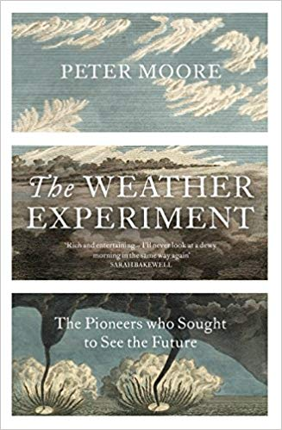


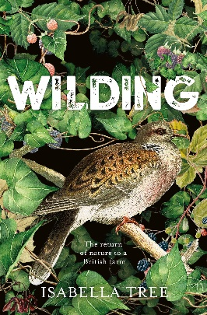
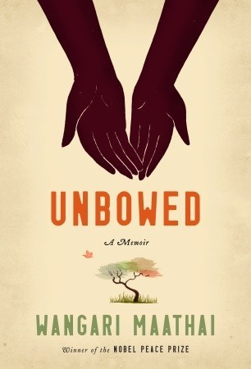


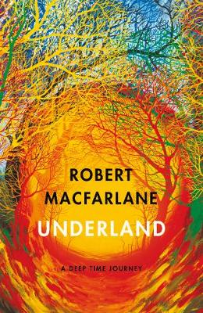


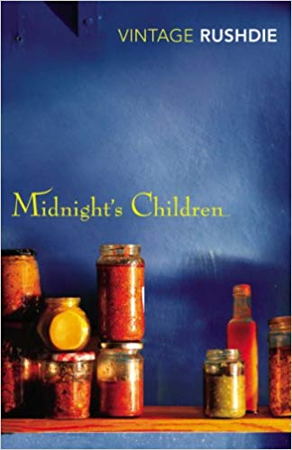
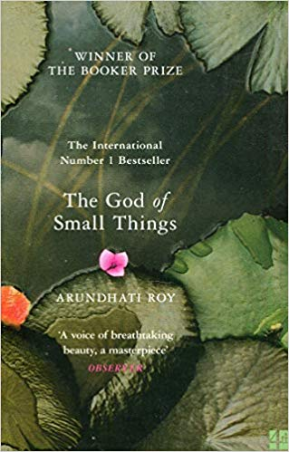
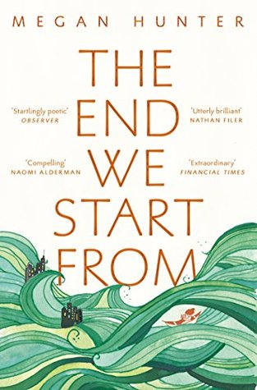
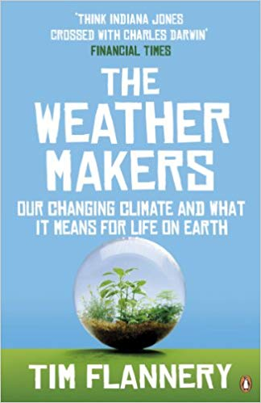
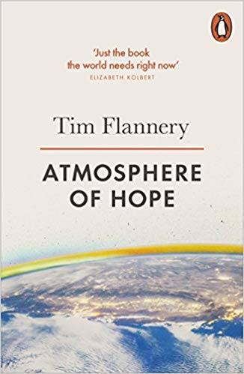
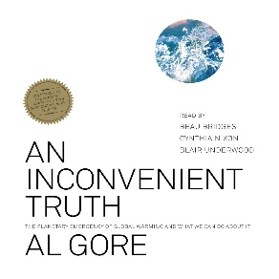
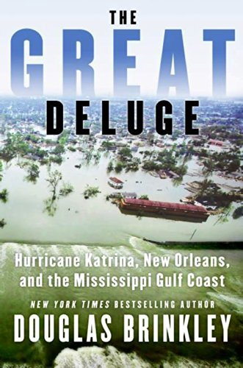
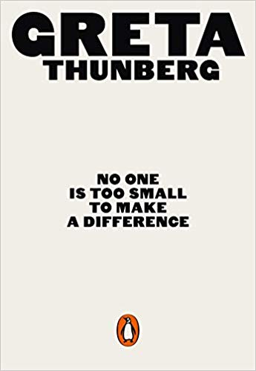
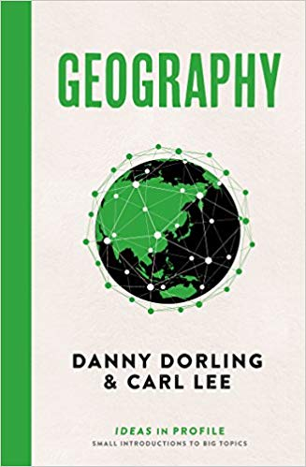
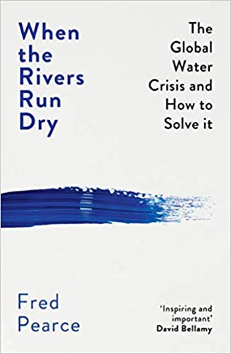

Kenya
City of Saints & Thieves
By Natalie C. Anderson

Restoring Natural Habitats
Wilding
By Isabella Tree

Kenya
Unbowed, A Memoir
By Wangari
Maathai

Global Inequalities
The Divide, A Brief Guide to Global Inequality and Its Solutions
By Jason Hickel
Kenya
The Constant Gardener
By John Le Carré

India
The Midnight Palace
By Carlos Ruiz Zafron

India
The White Tiger
By Aravind Adiga

India
Midnight’s Children
By Salman Rushdie

Weather
The Weather Makers
By Tim Flannery

Climate Change
No One is Too Small to Make a Difference
By Greta Thunberg

Climate Change
The End We Start From
By Megan Hunter

Climate Change
Geography, Ideas in Profile
By Danny Dorling & Carl Lee

An Inconvenient Truth
An Inconvenient Truth
By Al Gore

Management of Water Sources
When the Rivers Run Dry
By Fred Pearce

Water
Underland
By Robert
MacFarlane

Drought
Dry
By Neal Shusterman & Jarrod Shusterman

Extreme Weather
The Weather Experiment, The Pioneers Who Sought to See the Future
By Peter Moore

Extreme Weather
The Great Deluge, Hurricane Katrina, New Orleans, and the Mississippi Gulf Coast
By Douglas Brinkley

Climate Change
Atmosphere of Hope
By Tim Flannery

India
The God of Small Things
By Arundhati Roy

Year 11 Wider Reading: Geography

The Periodic Table
Nature’s Building Blocks, An A-Z Guide to the Elements byJohn Emsley

