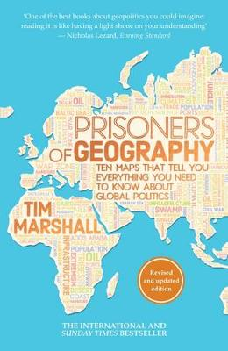
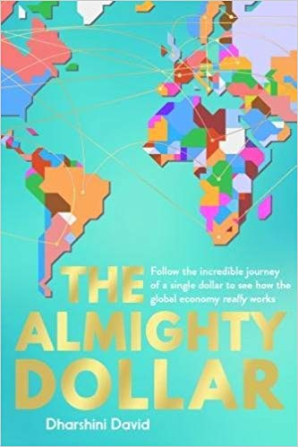
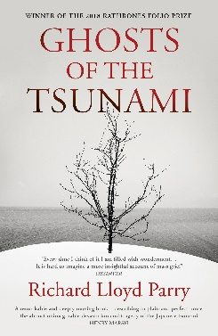
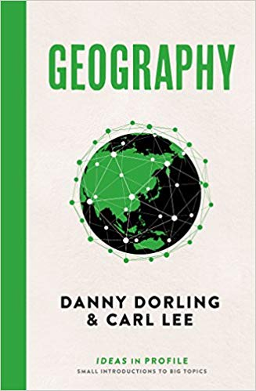
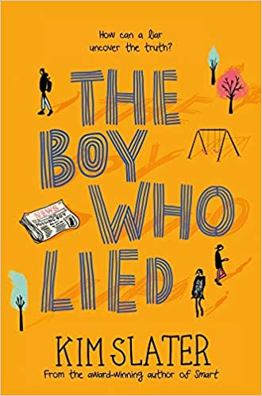
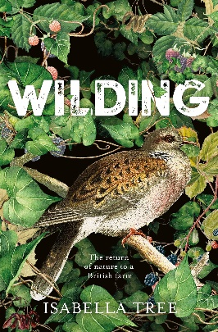
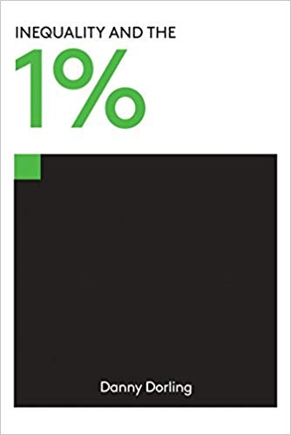
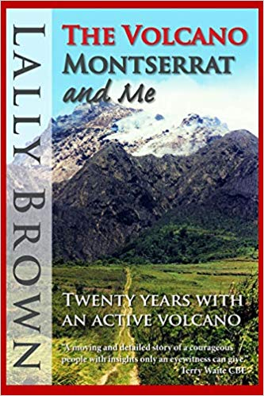
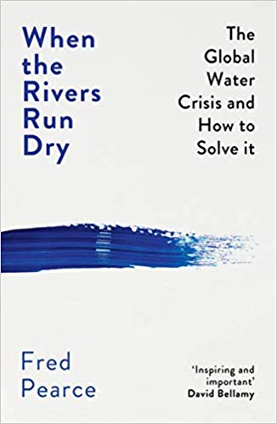
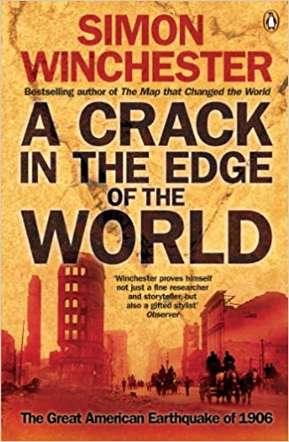
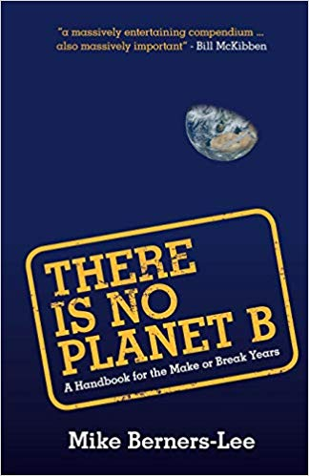
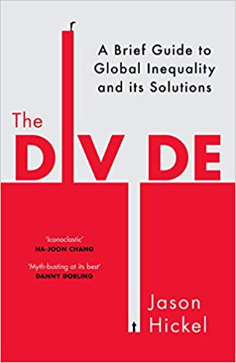
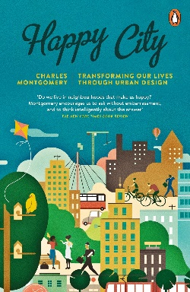
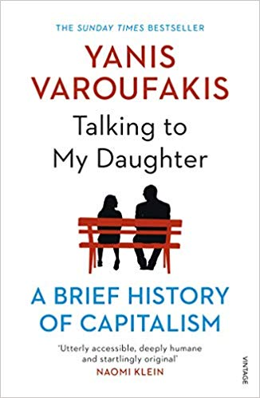
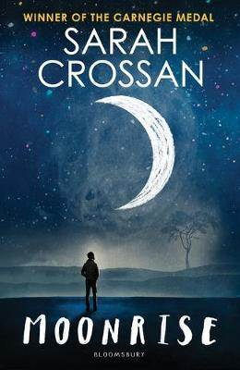
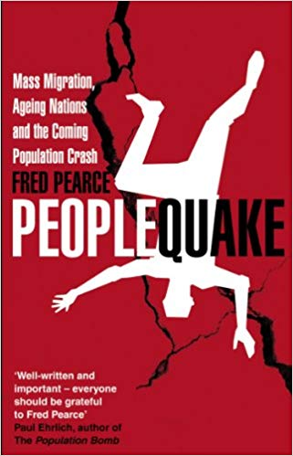

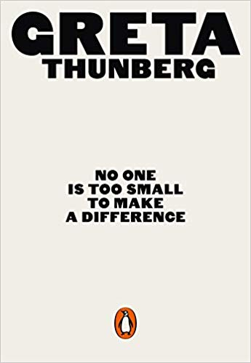
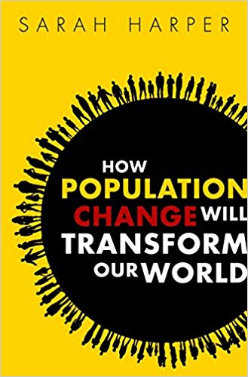
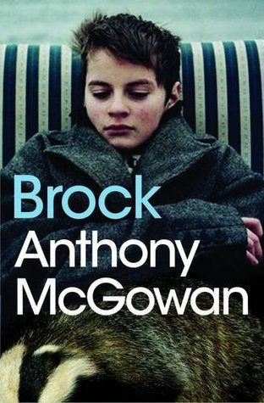
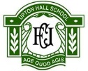
Physical Geography
Prisoners of Geography
By Tim Marshall

Economies
The Almighty Dollar
By Dharshini David

Volcanic Activity
Ghosts of the Tsunami
By Richard Lloyd Parry

Inequality
Geography, Ideas in Profile
By Danny Dorling & Carl Lee

Inequality in the UK
The Boy Who Lied
By Kim Slater

Sustainable Communities in the UK
Wilding
By Isabella Tree

Volcanic Activity
The Volcano Montserrat and Me
By Lally Brown

Rivers
When the Rivers Run Dry
By Fred Pearce

Volcanic Activity
A Crack in the Edge of the World
By Simon Winchester

Flooding
There is No Planet B
By Mike Berners-Lee

Global Inequalities
The Divide, A Brief Guide to Global Inequality and Its Solutions
By Jason Hickel
Housing
Happy City, Transforming our Lives through Urban Design
By Charles Montgomery

Population
Peoplequake, Mass Migration, Ageing Nations and the Coming Population Crash
By Fred Pearce

Population
Scythe
By Neal Shusterman

Population
How Population Change Will Transform our World
By Sarah Harper

Inequality in the UK
Brock
By Anthony McGowan
Inequality
Moonrise
By Sarah Crossan

Global Inequalities
Inequalities and the 1%
By Danny Dorling

Economies
Talking to My Daughter, A Brief History of Capitalism
By Yanis Yaroufakis

Geography in the News
No One is Too Small to Make a Difference
By Greta Thunberg

Year 10 Wider Reading: Geography

The Periodic Table
Nature’s Building Blocks, An A-Z Guide to the Elements byJohn Emsley

