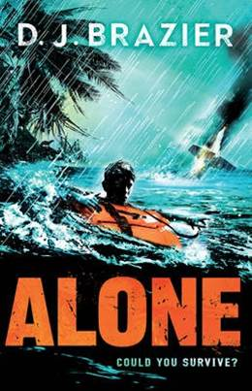
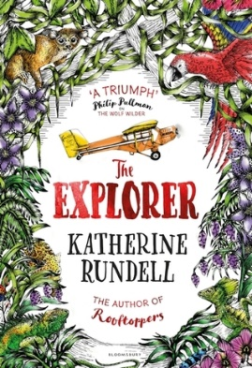
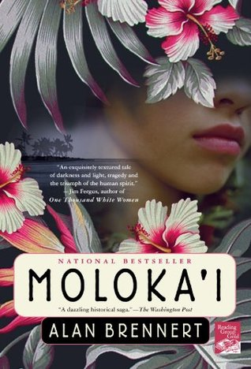
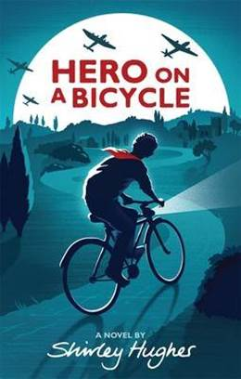

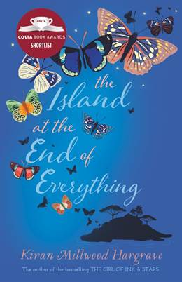
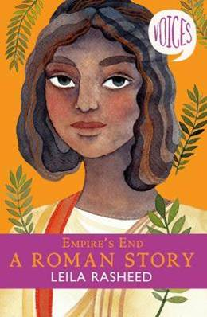
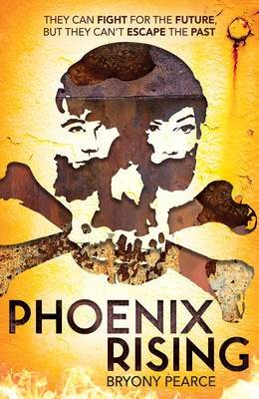
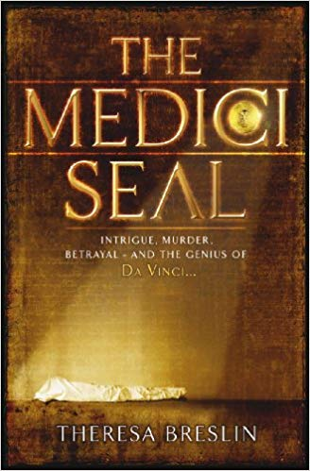
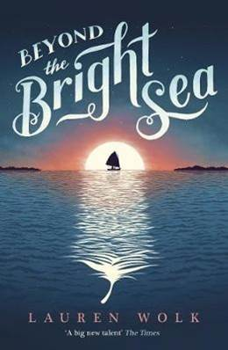


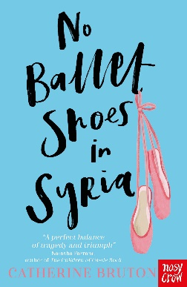
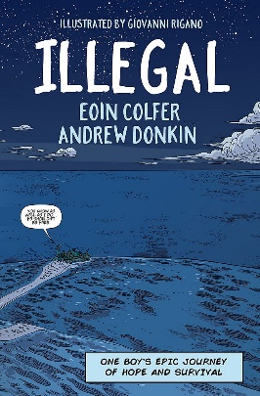

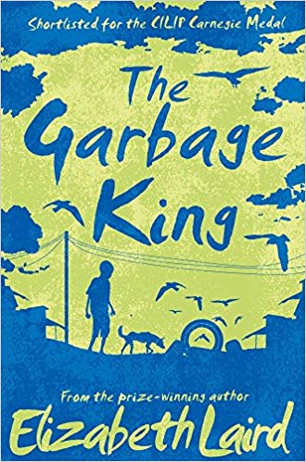
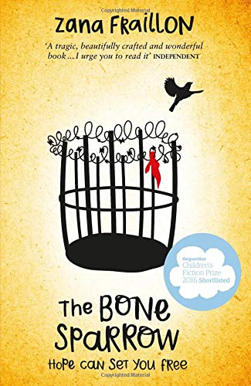
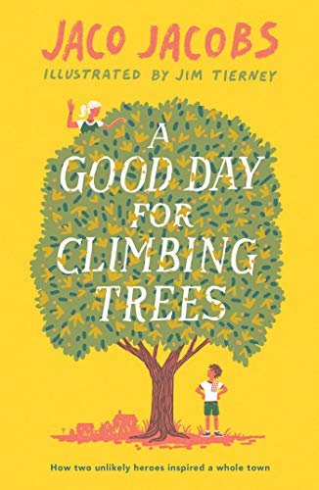
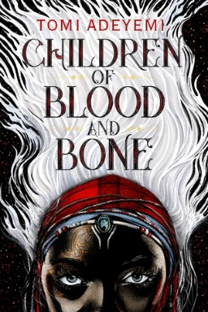
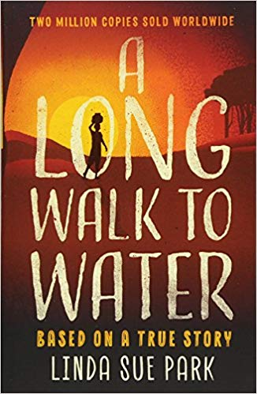
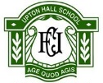
Tropical Storms
Alone
By D. J. Brazier

Brazil
The Explorer
By Katherine Rundell

Disease
Moloka’i
By Alan Brennert

Italy
Hero on a Bicycle
By Shirley Hughes

Brazil
Ultimate Football Heroes, Marta
By Charlotte Browne

Disease
The Island at the End of Everything
By Kiran Millwood Hargrave

Italy
Empire’s End, A Roman Story
By Leila Rasheed

Italy
The Medici Seal
By Theresa Breslin

Fossil Fuels and Alternative Sources
Phoenix Rising
By Bryony Pearce

Geography in the News
No Ballet Shoes in Syria
By Catherine Bruton

Disease
Beyond the Bright Sea
By Lauren Wolk

Year 8 Wider Reading: Geography
Africa
The Garbage King
By Elizabeth Laird

Africa
Illegal
By Eoin Colfer & Andrew Donkin

Africa
Burn my Heart
By Beverley Naidoo

Africa
Children of Blood and Bone
By Tomi Adeyemi

Kenya
A Long Walk to Water
By Linda Sue Park

Italy
Stravaganza, City of Secrets
By Mary Hoffman

Geography in the News
The Bone Sparrow
By Zana Fraillon

Africa
The Ghosts & Jamal
By Bridget Blankley

Africa
A Good Day for Climbing Trees
By Jaco Jacobs

The Periodic Table
Nature’s Building Blocks, An A-Z Guide to the Elements byJohn Emsley

