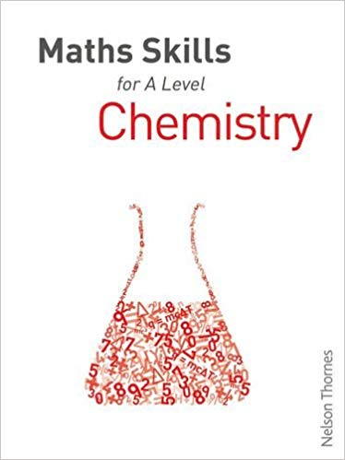
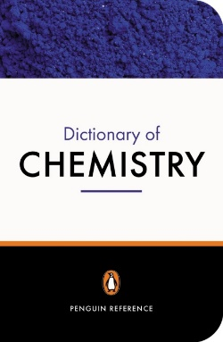
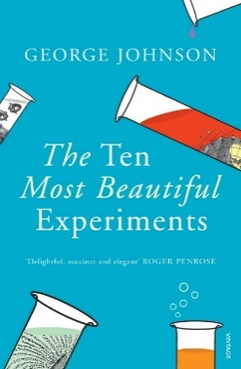
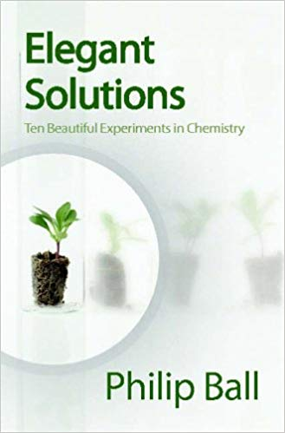
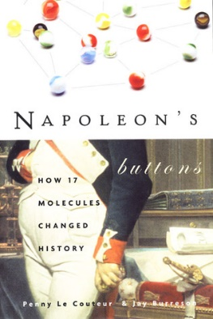
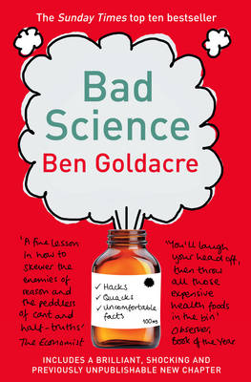
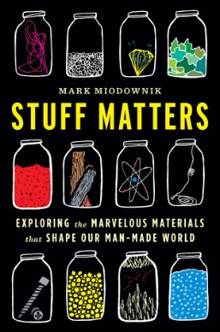
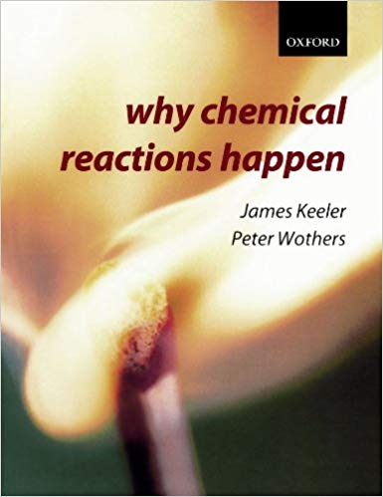
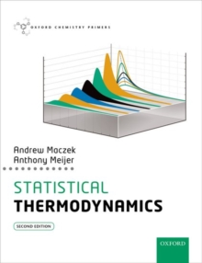
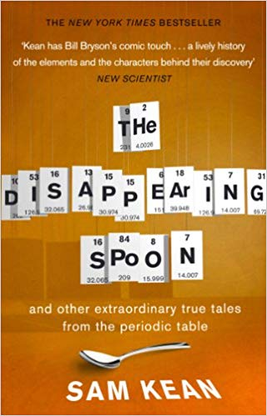
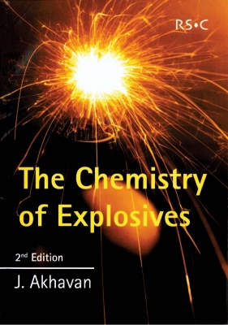
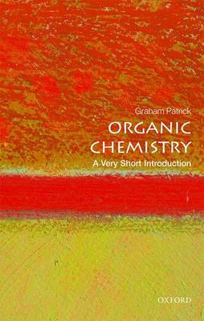
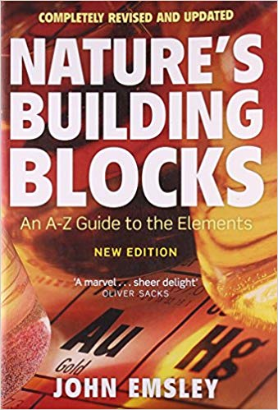
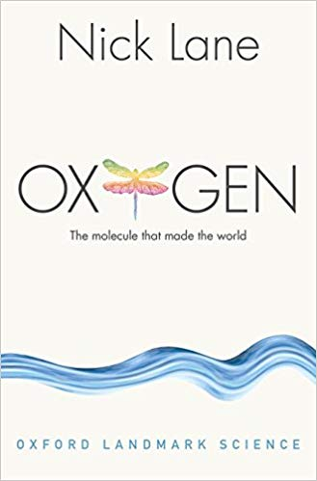
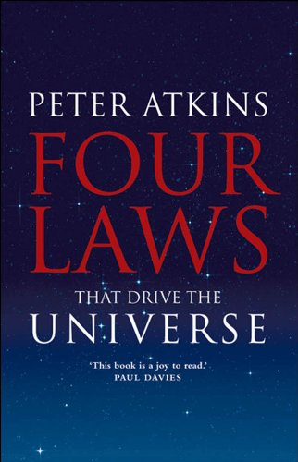
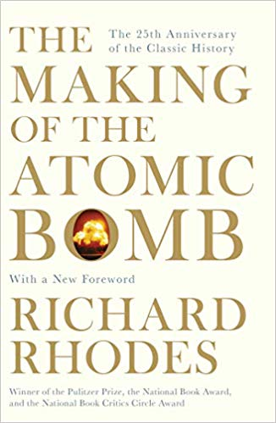
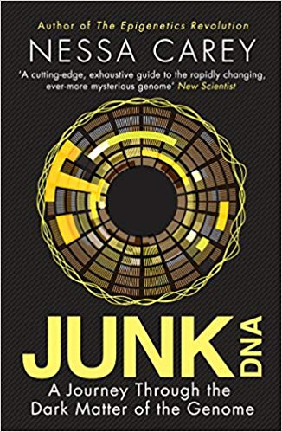
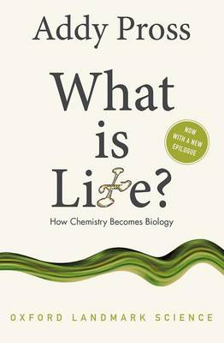
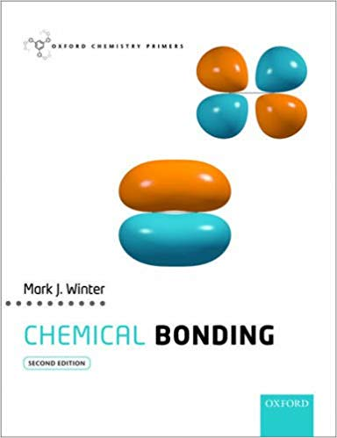
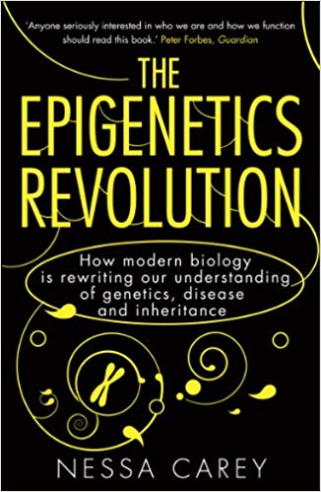
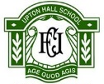
For Reference
Dictionary of Chemistry
Penguin

History of Chemistry
The Ten Most Beautiful Experiments
By George Johnson

Wider Chemistry
Maths Skills for A Level Chemistry
Nelson Thornes
History of Chemistry
Napoleon’s Buttons, How 17 Molecules Changed History
By Penny Le Couteur & Jay Burreson

Wider Chemistry
Bad Science
By Ben Goldacre
Properties of Matter
Stuff Matters, Exploring the Marvelous Materials that Shape our Man-Made World
By Mark Miadownik

Bonding
Why Chemical Reactions Happen
By James Keeler & Peter Wothers

Thermodynamics
Statistical Thermodynamics
By Andrew Maczek & Anthonu Meijer
The Periodic Table
The Disappearing Spoon
By Sam Kean

Combustion
The Chemistry of Explosives
By J. Akhavan
Organic Chemistry
Organic Chemistry, A Very Short Introduction
By Graham Patrick
The Periodic Table
Nature’s Building Blocks, An A-Z Guide to the Elements
By John Emsley

DNA
The Epigenetics Revolution
By Nessa Carey

Wider Chemistry
Elegant Solutions
By Philip Ball

Thermodynamics
Four Laws that Drive the Universe
By Peter Atkins

Wider Chemistry
What is Life?
By Addy Pross

Wider Chemistry
The Making of the Atomic Bomb
By Richard Rhodes

Bonding
Chemical Bonding
By Mark J. Winter

DNA
Junk DNA
By Nessa Carey

Molecules
Oxygen, The Molecule that Made the World
By Nick Lane

KS5 Wider Reading: Chemistry
The Periodic Table
Nature’s Building Blocks, An A-Z Guide to the Elements byJohn Emsley

