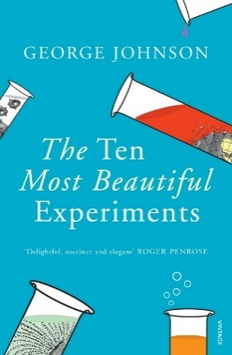
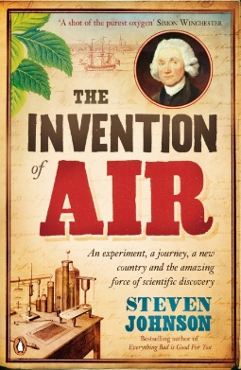
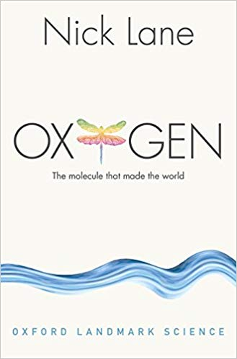
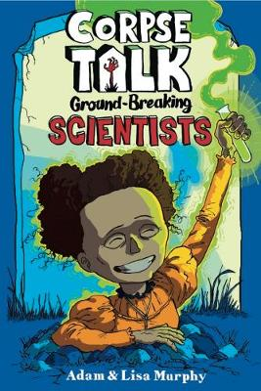
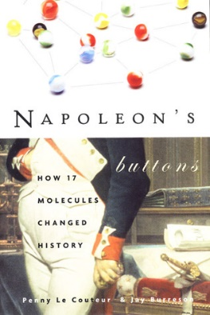
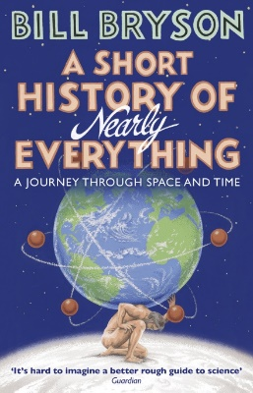
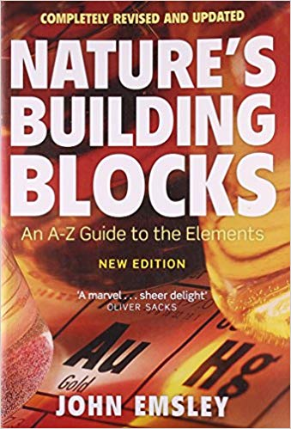
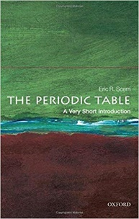
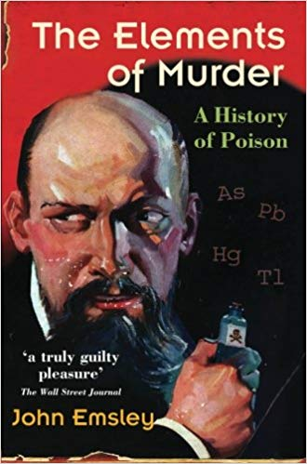
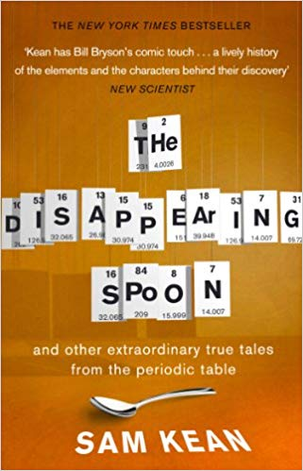
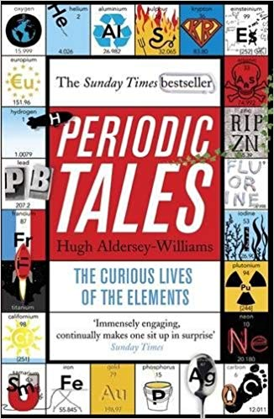
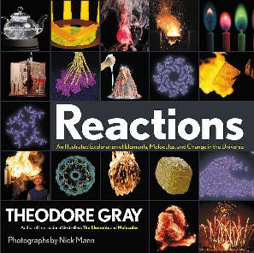
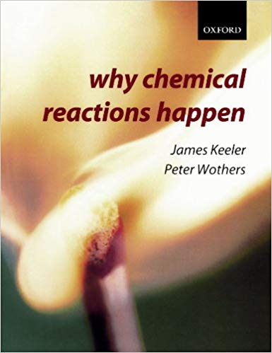
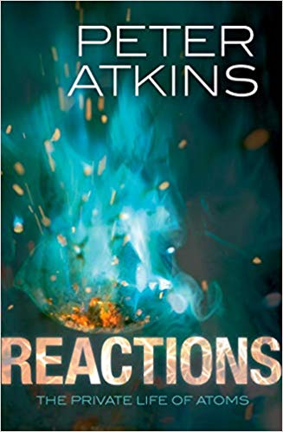
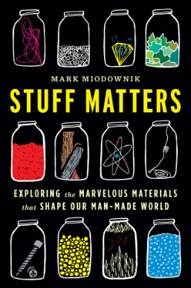
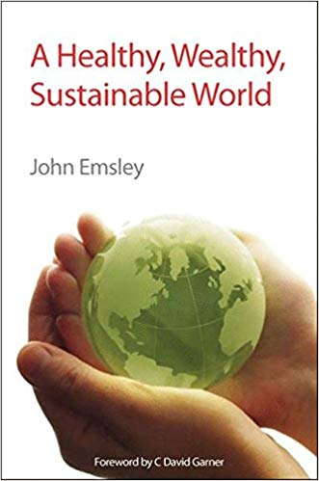
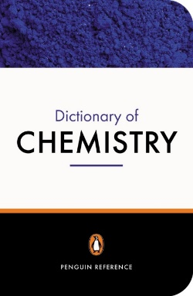
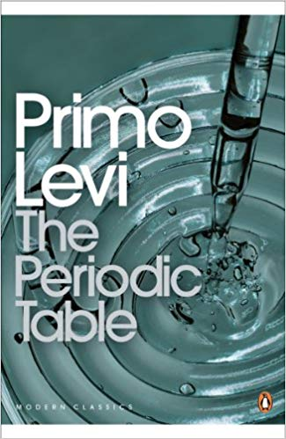
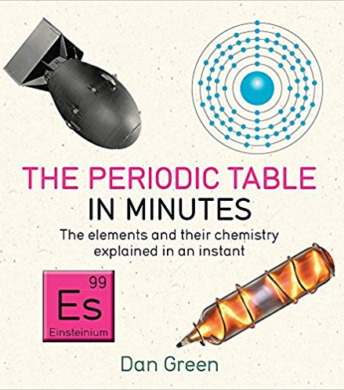
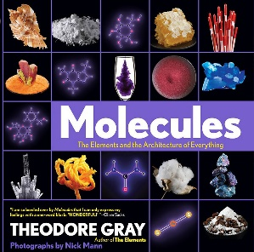
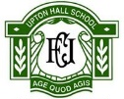
History of Chemistry
Corpse Talk, Ground Breaking Scientists
By Adam & Lisa Murphy

History of Chemistry
Napoleon’s Buttons, How 17 Molecules Changed History
By Penny Le Couteur & Jay Burreson

Reactions
Reactions, An Illustrated Exploration of Elements, Molecules, and Change in the Universe
By Theodore Gray

Sustainable Development
A Healthy, Wealthy, Sustainable World
By John Emsley

For Reference
Dictionary of Chemistry
Penguin

History of Chemistry
A Short History of Nearly Everything, A Journey Through Space and Time
By Bill Bryson

Molecules
The Elements of Murder, A History of Poison
By John Emsley

The Periodic Table
Nature’s Building Blocks, An A-Z Guide to the Elements
By John Emsley

The Periodic Table
The Periodic Table, A Very Short Introduction
By Eric R. Scerri

History of Chemistry
The Ten Most Beautiful Experiments
By George Johnson

History of Chemistry
The Invention of Air
By Steven Johnson

The Periodic Tale
Periodic Tales, The Curious Lives of the Elements
By Hugh Aldersey-Williams

Molecules
Oxygen, The Molecule that Made the World
By Nick Lane

Reactions
Why Chemical Reactions Happen
By James Keeler & Peter Wothers

Reactions
Reactions, The Private Life of Atoms
By Peter Atkins

Properties of Matter
Stuff Matters, Exploring the Marvelous Materials that Shape our Man-Made World
By Mark Miadownik

The Periodic Table
The Disappearing Spoon
By Sam Kean

Molecules
Molecules, The Elements and the Architecture of Everything
By Theodore Gray

The Periodic Table
The Periodic Table
By Primo Levi

The Periodic Table
The Periodic Table in Minutes
By Dan Green

KS4 Wider Reading: Chemistry
The Periodic Table
Nature’s Building Blocks, An A-Z Guide to the Elements byJohn Emsley

