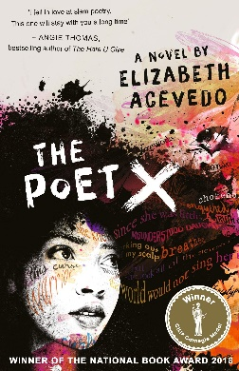
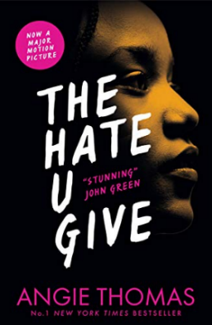

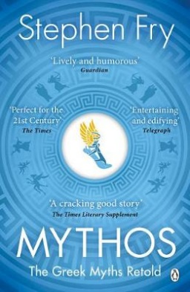
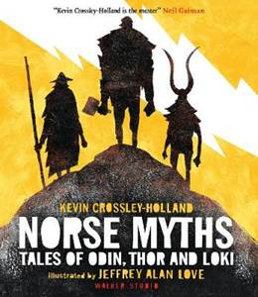
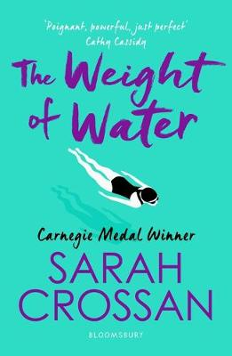
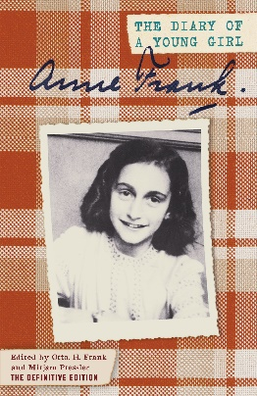
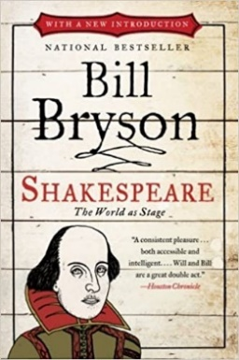

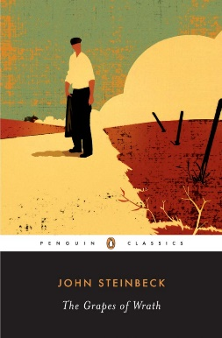
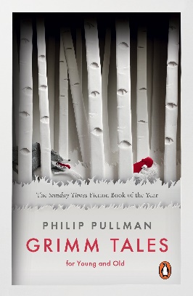
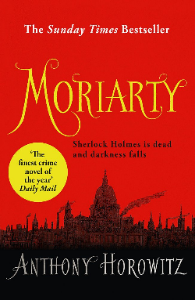
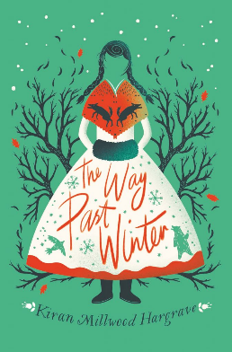
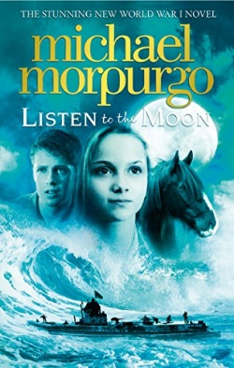
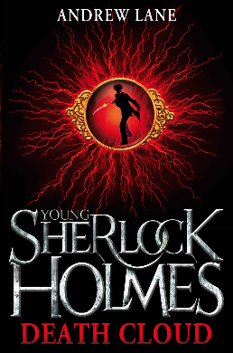
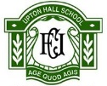
Fairy Tales
Grimm Tales, For Young and Old
By Philip Pullman

Rooftoppers
The Good Thieves
By Katherine Rundell

Private Peaceful
Listen to the Moon
By Michael Morpurgo

The Girl of Ink and Stars
The Island at the End of Everything
By Kiran Millwood Hargrave

Private Peaceful
War Horse
By Michael Morpurgo

Romeo and Juliet
Noughts and Crosses
By Malorie Blackman

Of Mice and Men
The Grapes of Wrath
By John Steinbeck

Shakespeare
Shakespeare, The World as Stage
By Bill Bryson

Greek Myths
Mythos, The Greek Myths Retold
By Stephen Fry
KS3 Wider Reading: English
Sherlock Holmes
Young Sherlock Holmes, Death Cloud
By Andrew Lane

Sherlock Holmes
Moriarty
By Anthony Horowitz

African American Female Writers
The Hate U Give
By Angie Thomas

Parent and Child Poetry
The Poet X
By Elizabeth Acevdo

Fairy Tales
Cinder, The Lunar Chronicles
By Marissa Meyer

The Girl of Ink and Stars
The Way Past Winter
By Kiran Millwood Hargrave

Rooftoppers
The Wolf Wilder
By Katherine Rundell

Fairy Tales
The House with the Chicken Legs
By Sophie Anderson

Greek Myths
Norse Myths, Tales of Odin, Thor and Loki
By Kevin Crossley-Holland

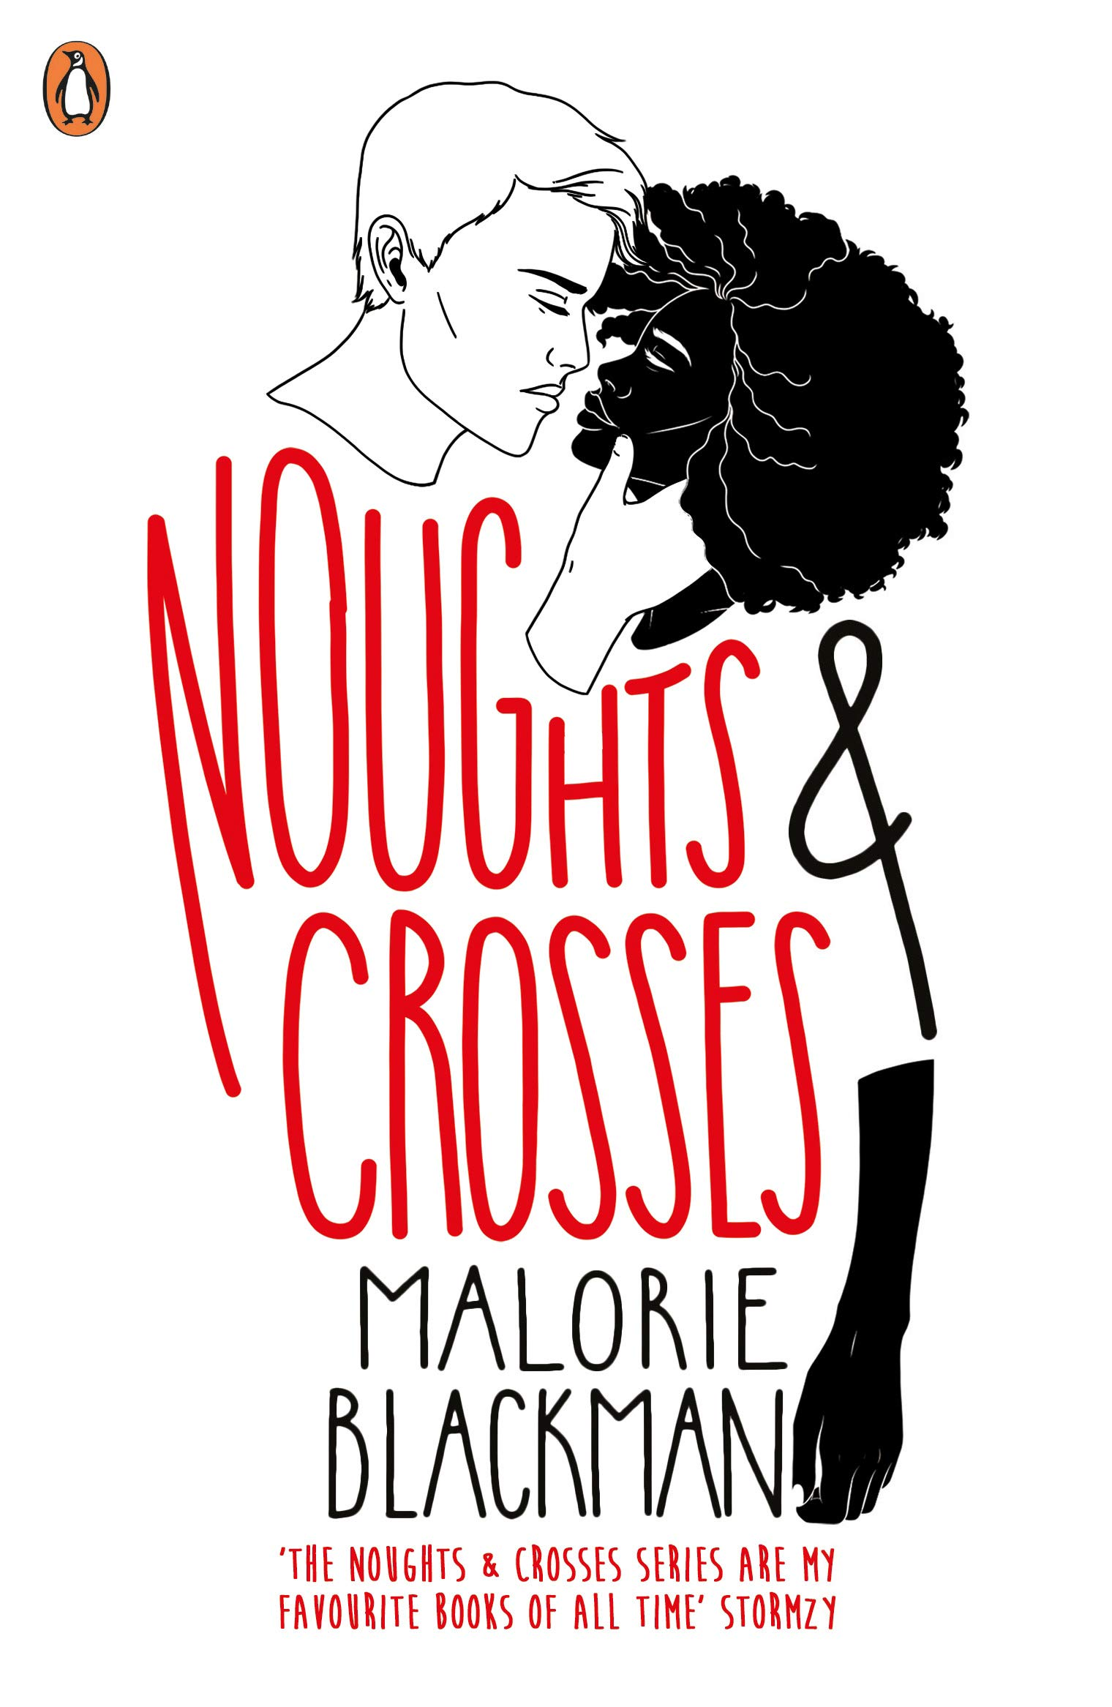

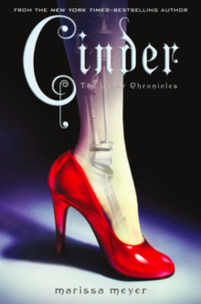
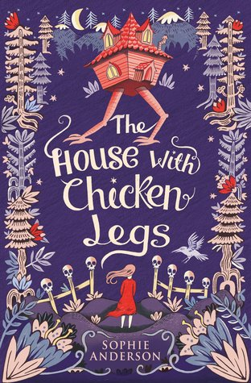
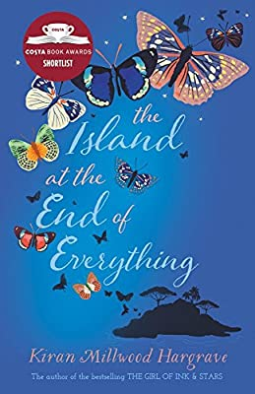
Letters in Fiction
Anne Frank, The Diary of a Young Girl
By Anne Frank

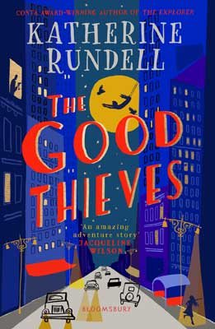

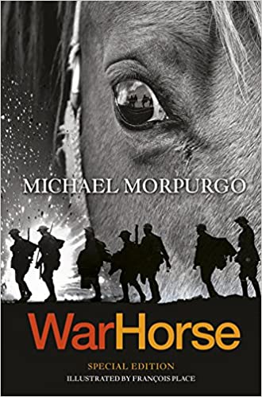

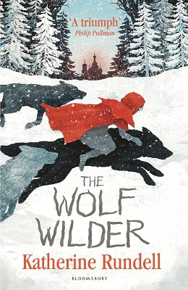

Poetry
The Weight of Water
By Sarah Crossan

The Periodic Table
Nature’s Building Blocks, An A-Z Guide to the Elements byJohn Emsley

