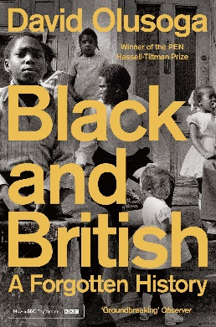
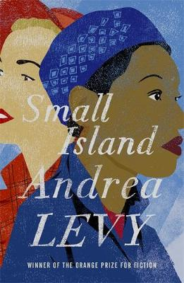
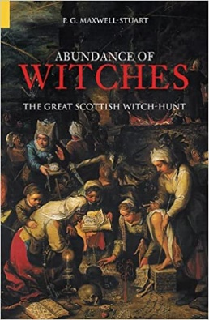
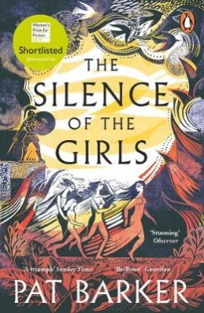
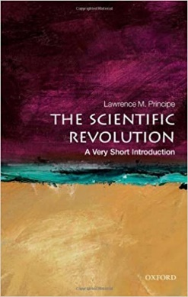
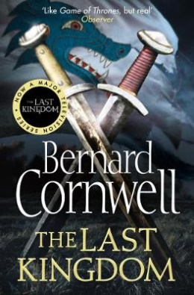
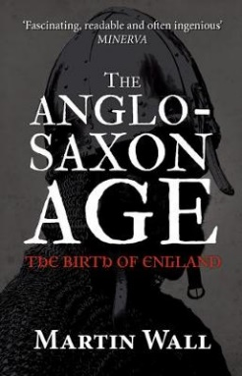
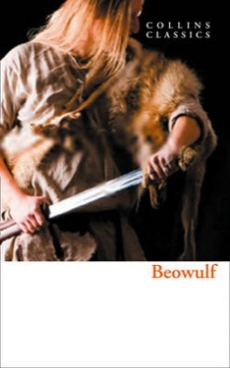
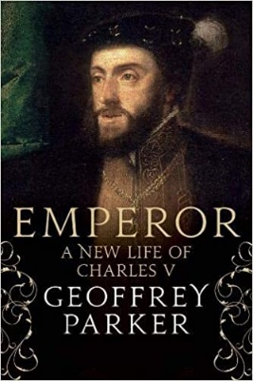
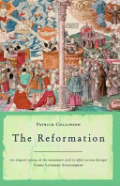
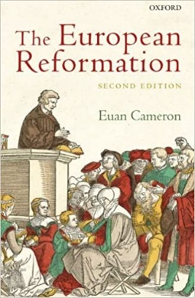
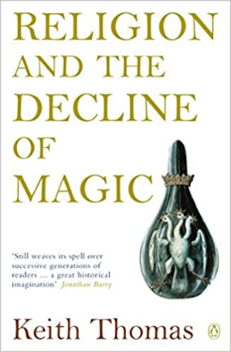
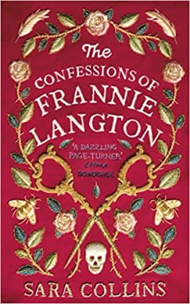
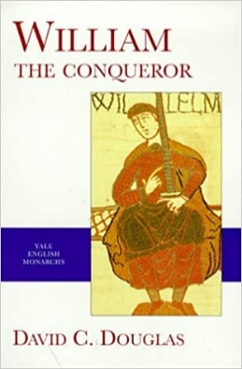
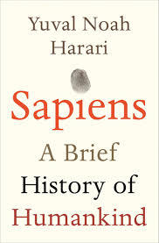


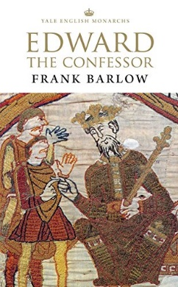
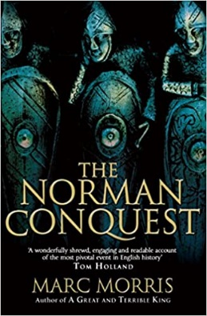
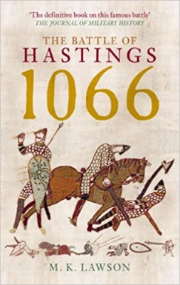

Wider History
Black and British, A Forgotten History
By David Olusoga

Witch Craze
Abundance of Witches, The Great Scottish Witch-Hunt
By P. G. Maxwell-Stuart

Wider History
The Silence of the Girls
By Pat Barker

Witch Craze
The Scientific Revolution, A Very Short Introduction
By Lawrence M. Principe

Anglo-Saxon England
The Last Kingdom
By Bernard Cornwell

Anglo-Saxon England
The Anglo-Saxon Age, The Birth of England
By Martin Wall

Wider History
Small Island
By Andrea Levy

The Norman Conquest
William the Conqueror
By David C. Douglas
German Reformation
The Reformation
By Patrick Collinson

German Reformation
The European Reformation
By Euan Cameron

The Norman Conquest
The Battle of Hastings 1066
By M.K. Lawson

Witch Craze
The Crucible
By Arthur Miller
Charles V
Emperor, A New Life of Charles V
By Geoffrey Parker

The Norman Conquest
The Norman Conquest
By Marc Morris

Anglo-Saxon England
Edward the Confessor
By Frank Barlow

Wider History
Wolf Hall
By Hilary Mantel

Anglo-Saxon England

Beowulf

Wider History
Sapiens, A Brief History of Humankind
By Yuval Noah Harari

KS5 Wider Reading: History
Witch Craze
Religion and the Decline of Magic
By Keith Thomas

Wider History
The Confessions of Frannie Langton
By Sara Collins

The Periodic Table
Nature’s Building Blocks, An A-Z Guide to the Elements byJohn Emsley

