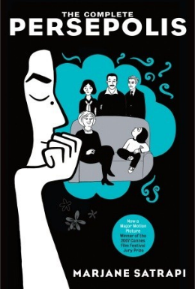
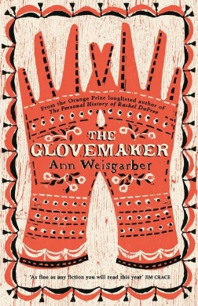
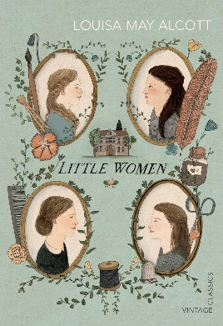

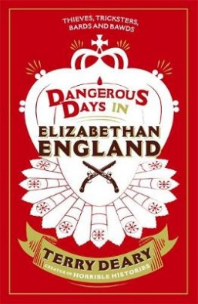
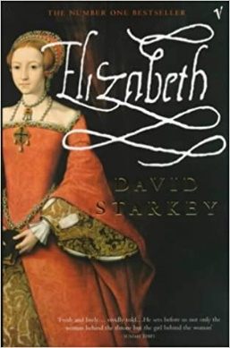
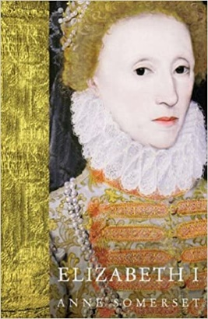
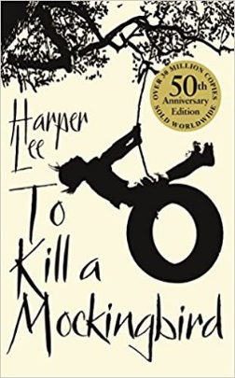
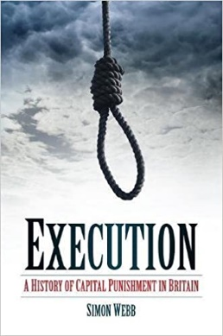
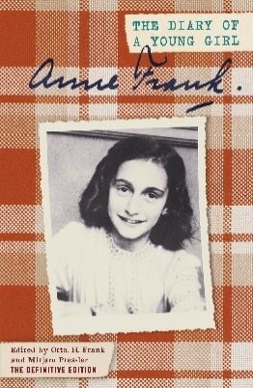
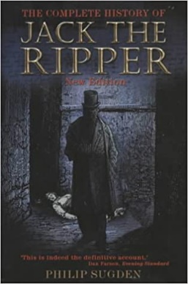
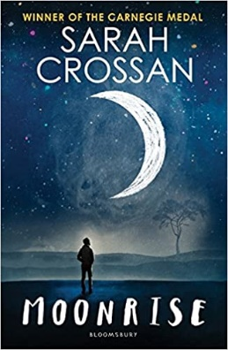
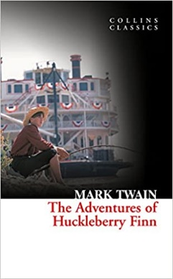
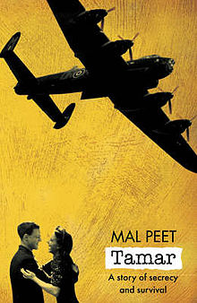
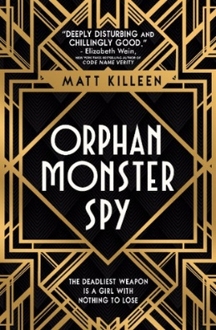
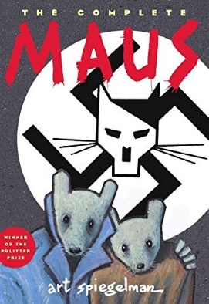
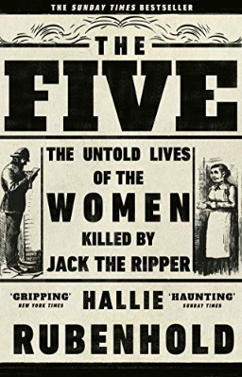
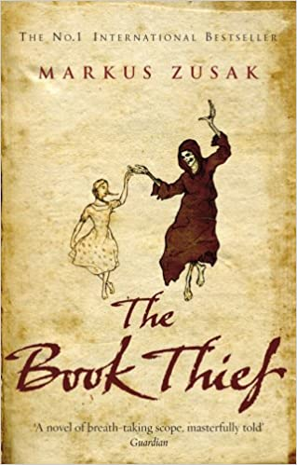

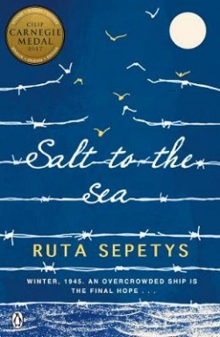

Nazi Germany
The Diary of Anne Frank
By Anne Frank

Wider History
Persepolis
By Marjane Satrapi

Nazi Germany
The Book Thief
By Marcus Zusak

Crime and Punishment
To Kill a Mockingbird
By Harper Lee

Whitechapel Murders
The Five, The Untold Lives of the Women Killed by Jack the Ripper
By Hallie Rubenhold

Whitechapel Murders
The Complete History of Jack the Ripper
By Philip Sugden

Nazi Germany
Tamar
By Mal Peet
Elizabeth I
Dangerous Days in Elizabethan England
By Terry Deary

19th Century America
Little Women
By Louisa May Alcott

Elizabeth I
Elizabeth I
By Anne Somerset

Crime and Punishment
Execution, A History of Capital Punishment in Britain
By Simon Webb

Crime and Punishment
Moonrise
By Sarah Crossan

Nazi Germany
Orphan Monster Spy
By Matt Killeen

19th Century America
The Glovemaker
By Ann Weisgarber

Elizabeth I
Elizabeth
By David Starkey

Nazi Germany
Maus
By Art Spiegelman

Wider History
The Fountains of Silence
By Ruta Sepetys

KS4 Wider Reading: History
Elizabeth I
The Lady Elizabeth
By Alison Weir

19th Century America
The Adventures of Huckleberry Finn
By Mark Twain

Wider History
Salt to the Sea
By Ruta Sepetys

The Periodic Table
Nature’s Building Blocks, An A-Z Guide to the Elements byJohn Emsley

