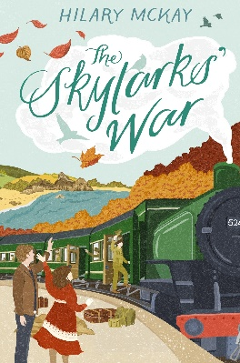
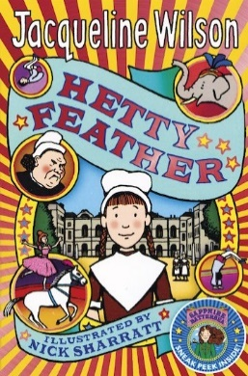
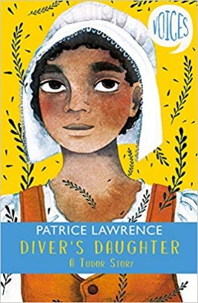
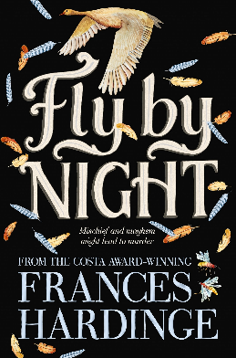
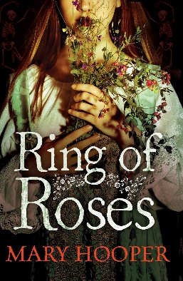
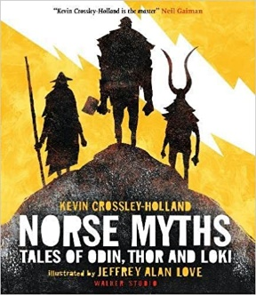
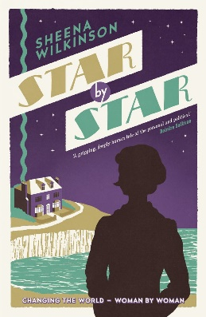
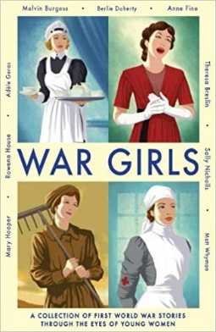
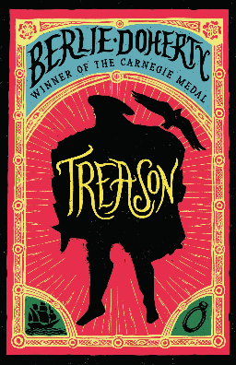
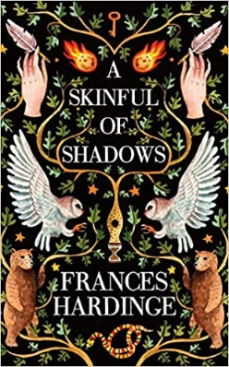
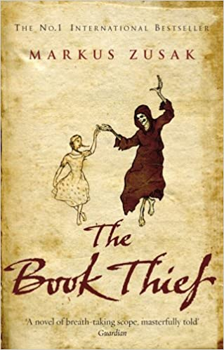
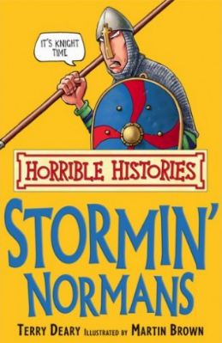
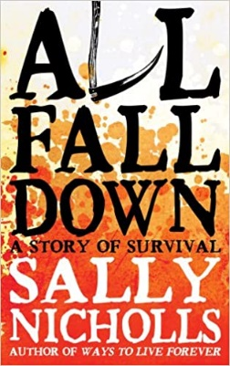
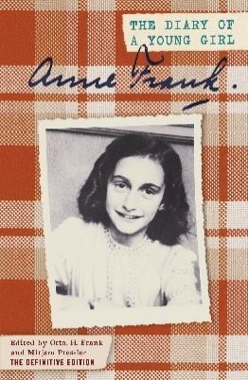
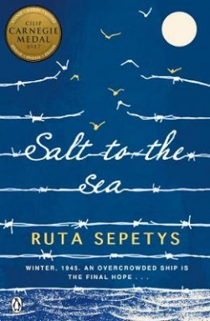
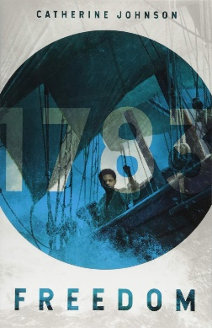
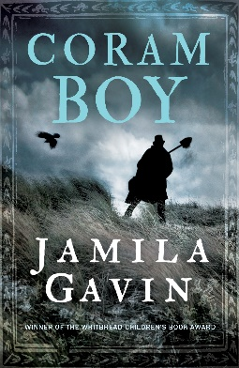
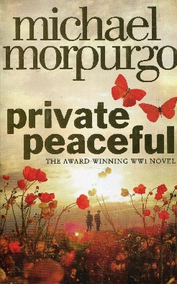
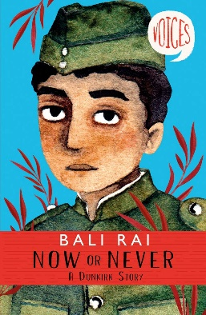
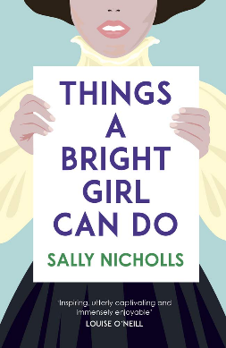
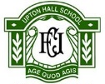
Tudors
Diver’s Daughter, A Tudor Story
By Patrice Lawrence

World War One
The Skylark’s War
By Hilary McKay

Industrial Revolution
Hetty Feather
By Jacqueline Wilson

English Civil War
Fly by Night
By Frances Hardinge

Vikings
Norse Myths, Tales of Odin, Thor and Loki
By Kevin Crossley-Holland & illustrated by Jeffrey Alan Love

Suffragettes
Star by Star
By Sheena Wilkinson
Slavery
Coram Boy
By Jamila Gavin

World War One
War Girls
By Teresa Breslin et al.

Tudors
Treason
By Berlie Doherty

English Civil War
A Skinful of Shadows
By Frances Hardinge

The Black Death
All Fall Down, A Story of Survival
By Sally Nicholls

Rise of Dictators
Anne Frank, The Diary of a Young Girl
By Anne Frank

World War One
Private Peaceful
By Michael Morpurgo

The Black Death
Ring of Roses
By Mary Hooper

Normans
Stormin’ Normans
By Terry Deary & illustrated by Martin Brown

World War Two
Now or Never, A Dunkirk Story
By Bali Rai

KS3 Wider Reading: History
Suffragettes
Things A Bright Girl Can Do
By Sally Nicholls

Slavery
Freedom 1783
By Catherine Johnson

World War Two
Salt to the Sea
By Ruta Sepetys

Nazi Germany
The Book Thief
By Marcus Zusak

The Periodic Table
Nature’s Building Blocks, An A-Z Guide to the Elements byJohn Emsley

