Upton Hall School FCJ

Uniform and Appearance – September 2019

At Upton Hall School FCJ, we believe that our uniform is essential to the ethos of our school community as it establishes a clear sense of identity, fosters a sense of inclusive belonging, and engenders both positive behaviour and self-discipline, which in turn support teaching and learning.

Pupils should wear their uniform with pride. Visitors to the school and members of the public frequently remark on how smart Upton girls look in their uniform. Pupils should continue in this tradition by keeping their uniforms smart and clean. Pupils should ensure that their shoes are comfortable as they will do much more walking than they do in Primary School and there are many more flights of stairs to negotiate every day.

If pupils do not have the correct uniform, they may be sent home to leave non uniform items at home and return in the appropriate ones. In these circumstances, they are expected to return to school immediately. All pupils are required to wear school uniform in school and when travelling to and from school.

Pupils are allowed to wear a watch. This should not be a Smart Watch. Earrings, both clear plastic and metal (in lower and upper lobes) are not permitted. Plasters covering earrings are not permitted. If ears are to be pierced, this should be at the start of a holiday so that the earrings can be removed by the time school commences. Other jewellery such as bracelets and necklaces must not be worn. Hair, if long, must be tied back neatly. If hair is to be dyed, it must be a natural colour.

Hair bands and ribbons must be either black or green. Hats or other head coverings are not permitted. Make-up and nail varnish (including fake nails) are not allowed. This includes the excessive use of fake tan. If pupils come to school in make-up, they will be asked to remove it with wipes provided. If they choose not to use the wipes or cannot remove the makeup with the wipes, they may be sent home to remove it there and are expected to return when they have done so.

AUTUMN TERM

COAT Green Blazer manufactured by David Luke (compulsory) - Code: 1154/2158

Plain black full length coat for bad weather only (any manufacturer)

SCARF Plain Black scarf with badge

No other form of outer clothing is allowed

SKIRT Green Regulation knee length skirt manufactured by Trutex - Code: GSA-GRN

BLOUSE Year s 7/8 - White long sleeved blouse to be worn with school tie (any manufacturer)

Years 9/10/11 - Fitted white open neck blouse with short sleeves manufactured by Trutex

TIE Years 7/8 - Green/Yellow as stocked by suppliers
PULLOVER Green regulation V-necked sweater in Courtelle
SHOES Black shoes that are leather or leather look and can be polished
Heels must measure no more than 1 – 1 ½ inches

Secure fastenings are essential and shoes should not have heavy soles

Pumps are not allowed

Boots may not be worn either in school or travelling to and from school TROUSERS Optional – Plain green regulation trouser stocked by Cain of Heswall TIGHTS Black tights or white ankle socks.
BAGS Plain black bag for books and other materials

All items of clothing and personal belongings must be clearly marked with the owner’s name.
(Name tapes can be ordered from the uniform stockists) Uniform is stocked by:
Cain of Heswall, 187 Telegraph Road, Heswall CH60 7SE
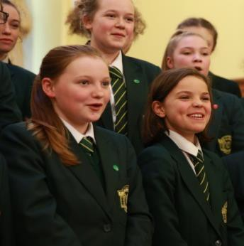
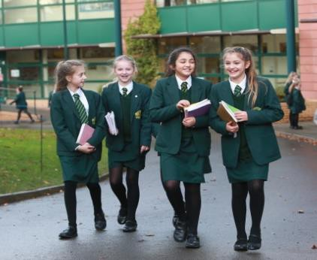
TEL: 0151 342 1769

SUMMER TERM

COAT Green Blazer manufactured by David Luke (compulsory) - Code: 1154/2158

Plain black full length coat for bad weather only (any manufacturer)

No other form of outer clothing is allowed

SKIRT Green Regulation knee length skirt manufactured by Trutex - Code: GSA-GRN BLOUSE Fitted white open neck blouse with short sleeves manufactured by Trutex PULLOVER Green regulation V-necked sweater in Courtelle
SHOES Black, well polished shoes

Heels must measure no more than 1 – 1 ½ inches

Secure fastenings are essential and shoes should not have heavy soles

Boots may not be worn either in school or travelling to and from school

TIGHTS Black tights or white ankle socks.

TROUSERS Optional – Plain green regulation trouser stocked by Cains

BAGS Plain black bag for books and other materials

All items of clothing and personal belongings must be clearly marked with the owner’s name.
(Name tapes can be ordered from the uniform stockists)

Uniform is stocked by:
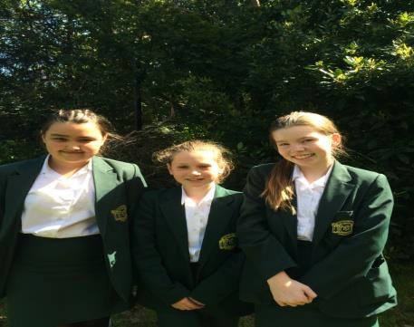
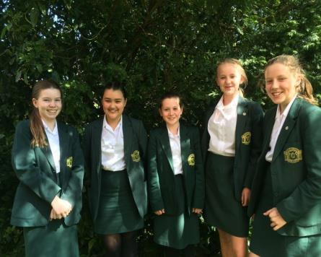
Cain of Heswall, 187 Telegraph Road, Heswall CH60 7SE TEL: 0151 342 1769

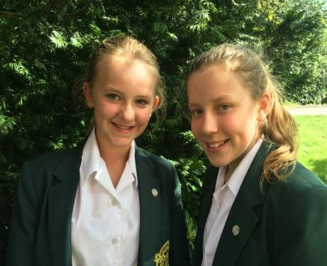

September 2018

Polo Manufactured by Falcon
Black/Emerald/White
(Name and Badge, Embroidered in Emerald)

Black Shorts Manufactured by Chadwick
(Name and Badge, Embroidered in Emerald)

Skort Manufactured by Falcon
Black/Emerald/White
(Name and Badge, Embroidered in Emerald)

Black Hoody Manufactured by Rowlinson–Woodbank
(Name and Badge, Embroidered in Emerald)

Black Tight Leggings Manufactured by Falcon

Black Track Trousers (optional) Manufactured by Falcon
(Name and Badge, Embroidered in Emerald)

3/4 Socks Manufactured by Falcon
Black/Emerald/White

School Kit Bag (with school badge)

One pair of PREDOMINANTLY WHITE Training Shoes One pair of shin pads (a gum shield is advisable)

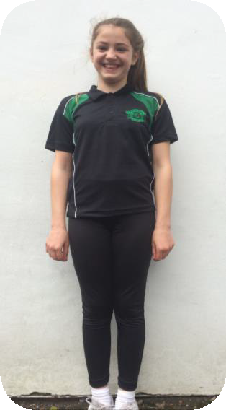
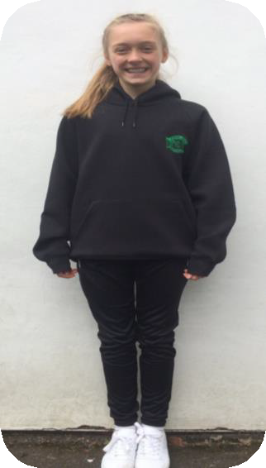
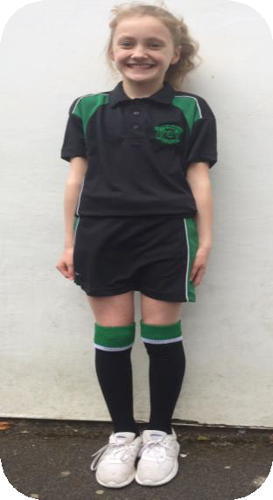
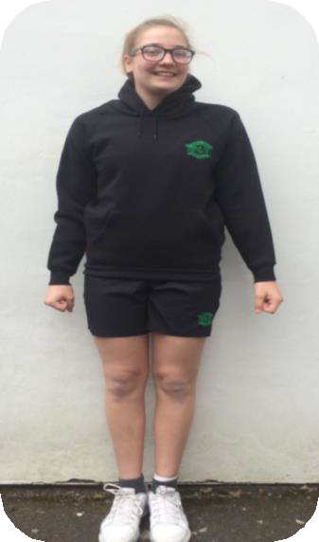
NO DARK SOLES WILL BE PERMITTED UNDER ANY CIRCUMSTANCES

