UPTON HALL SCHOOL FCJ
ANNUAL MASS




Saturday 4 November 2023 at 11.00am
INTRODUCTORY RITE
ENTRANCE HYMN
All stand and join in singing
Guide me, O thou great Redeemer,
pilgrim through this barren land;
I am weak, but thou art mighty,
hold me with thy powerful hand:
Bread of heaven, bread of heaven,
feed me till I want no more,
feed me till I want no more.

Open now the crystal fountain,
whence the healing stream doth flow;
let the fire and cloudy pillar
lead me all my journey through:
Strong Deliv'rer, strong Deliv'rer,
be thou still my strength and shield,
be thou still my strength and shield.

When I tread the verge of Jordan,
bid my anxious fears subside;
death of death and hell's destruction,
land me safe on Canaan's side:
Songs and praises, songs and praises,
I will ever give to thee,
I will ever give to thee.

GREETING
In the name of the Father,
and of the Son, and of the Holy Spirit.
R. Amen.
The Lord be with you.
R. And with your spirit.

PENITENTIAL RITE
Canon Niall Mullaley introduces the Mass and the Head Girl, Abigail Barker will welcome our special guests on behalf of the School. Canon Niall Mullaley then leads the Penitential Rite
R. Lord, have mercy.
R. Christ, have mercy.
R. Lord, have mercy.
GLORIA Soloist: Amelia Keane
All join in singing the responses R.
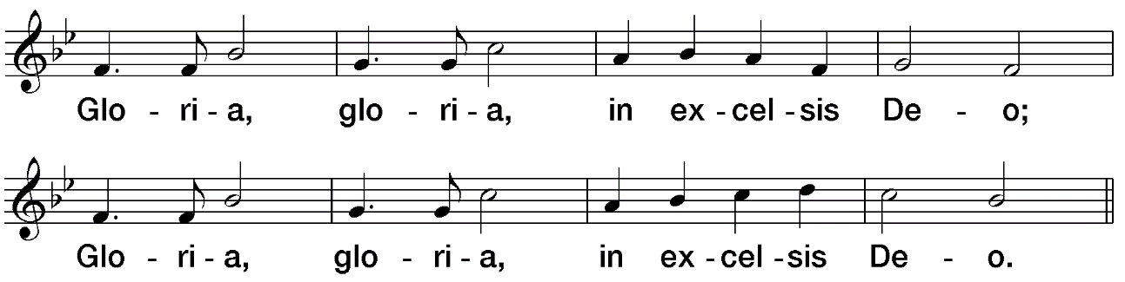

COLLECT
God of power and mercy,
protect us from all harm.
Give us freedom of spirit
and health in mind and body
to do your work on earth.
We ask this through our Lord Jesus Christ, your Son,
who lives and reigns with you and the Holy Spirit,
one God, for ever and ever. R. Amen.

LITURGY OF THE WORD
FIRST READING
Read by Erin O’Hare, Deputy Head Girl
A reading from Ecclesiasticus 6: 14-17
A faithful friend is a sturdy shelter:
he that has found one has found a rare treasure.
There is nothing so precious as a faithful friend,
and no scales can measure his excellence.
A faithful friend is an elixir of life;
and those who fear the Lord will find him.
Whoever fears the Lord directs his friendship aright,
for as he is, so is his neighbour also.

The Word of the Lord. R. Thanks be to God.
PSALM
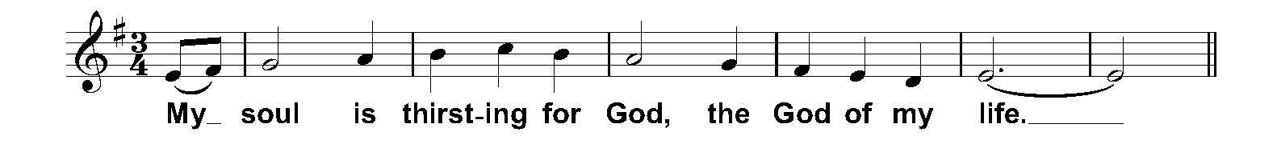
Sung by Alessia Saccucci
Psalm 41
Like the deer that yearns
for running streams,
so my soul is yearning
for you, my God.

My soul is thirsting for God,
the God of my life;
when can I enter and see
the face of God?

These things will I remember
as I pour out my soul:
how I would lead the rejoicing crowd
into the house of God,
amid cries of gladness and thanksgiving,
the throng wild with joy.

GOSPEL ACCLAMATION
The Book of the Gospels is carried in procession to the lectern.
All stand and join in singing after the Soloist, Rachael O’Connor
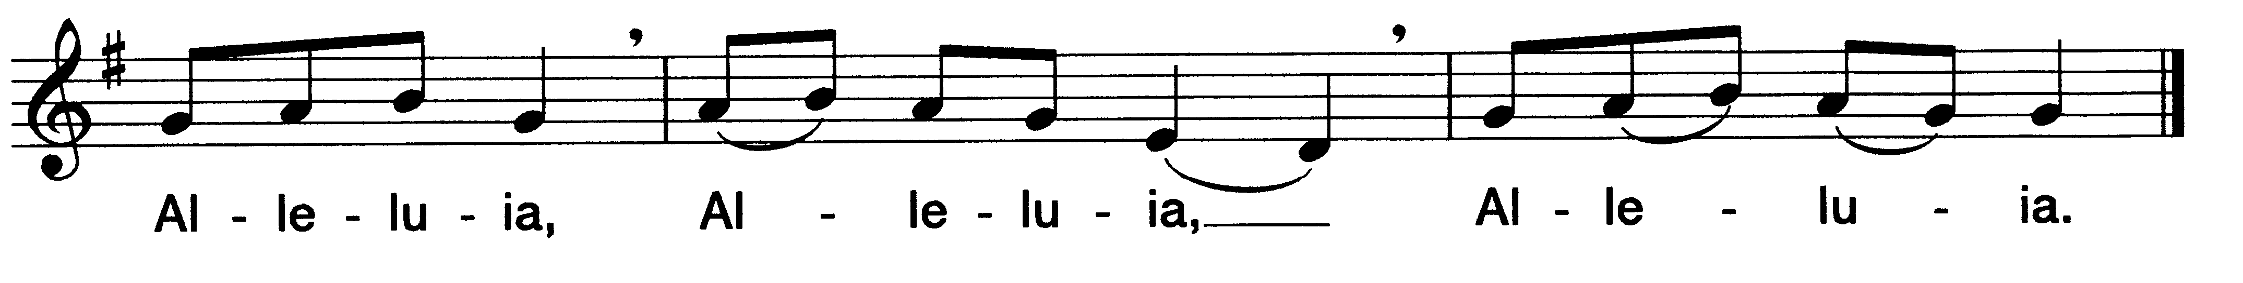

GOSPEL
The Lord be with you.
R. And with your Spirit.
A reading from the holy Gospel according to John 4: 7-15
R. Glory to you, O Lord.
Dear friends, let us love one another, for love comes from God. Everyone who loves has been born of God and knows God. Whoever does not love does not know God, because God is love. This is how God showed his love among us: He sent his one and only Son into the world that we might live through him. This is love: not that we loved God, but that he loved us and sent his Son as an atoning sacrifice for our sins. Dear friends, since God so loved us, we also ought to love one another. No one has ever seen God; but if we love one another, God lives in us and his love is made complete in us.
This is how we know that we live in him and he in us: He has given us of his Spirit. And we have seen and testify that the Father has sent his Son to be the Saviour of the world. If anyone acknowledges that Jesus is the Son of God, God lives in them and they in God. And so, we know and rely on the love God has for us.
The Gospel of the Lord. R. Praise to you, Lord Jesus Christ

HOMILY Canon Niall Mullaley

PRAYERS OF THE FAITHFUL
Bidding prayers to be read by members of the Upton Hall community.

All join in singing the response R. after each intention
R. O Lord hear my prayer, O Lord hear my prayer, when I call, answer me.
O Lord hear my prayer, O Lord hear my prayer, come and listen to me.
Read by Isabelle Wynn – Year 12
As we come together as a school community to give thanks for the gift of education, we pray that those who left us last summer will be happy and fulfilled in the next stage of their lives. We welcome all those who joined us in September, both students and staff, and ask that their time in Upton Hall School will be happy and fruitful. Instil in us all the values of hope, gentleness, dignity, justice, excellence and companionship. R.

Read by Gabby Ryan– Year 11
Thank you for giving us such a vibrant community of friends to do life with. We praise you for the people you have blessed us with, the ones who walk alongside us, to love, encourage, and uplift us through all of the twists and turns of life. We are so grateful Lord, that you have shown us your love through our companions. R.

Read by Phoebe McGregor – Year 10
This month of Remembrance, we pray for all those we’ve loved and have passed away. We pray especially for former companions of our school community; may they share in the fulness of the resurrection. We pray for their family and friends and for all those who are mourning. May they find consolation and strength in the faith that life is stronger than death. R.

Read by Hannah Kirkham – Year 9
We pray in thanks for Pope Francis and his continued guidance of our Most Holy Catholic Church. We pray that Pope Francis may continue to extend his blessings to all Catholics around the world to enable us to be the best version of ourselves. R.

Read by Beau Hodgers – Year 8
We pray for peace in our world and remember especially the people who are suffering from living in war torn countries. We pray for the many victims of war and we ask that a spirit of compassion will move those with the power in our world to stop their suffering. R.

Read by Alessia Saccucci – Year 13 (this prayer will be read in French)
En cette période d’incertitude politique, nous demandons à tous en tant que citoyen du monde d’être plus soucieux de l’humanité que nous partageons et de se tourner davantage vers l’extérieur. Nous prions pour que notre éducation nous enseigne avec dignité à apprécier la richesse de nos cultures diverses et à accueillir chaleureusement tous les étrangers. R.

English translation: In these days of political uncertainty, we ask that we may all be mindful of our shared humanity and that we look outwards as global citizens. May our education teach us to appreciate the richness of the diverse cultures amongst us and to make strangers welcome, seeking dignity for all. R.

Read by Amalie Hartley – Year 7
At Upton Hall we have many opportunities to make the world a better place. We pray for all the charities we are raising money for. We pray especially for the FCJ learning and development centre in the Philippines and the many local charities we support. May our prayers and actions bring hope and justice to those who are less fortunate. R.

Charlotte Henriksen – Year 13 leads the Hail Mary in Spanish – please join in if possible. We offer all our prayers, both spoken and in the gentleness of our hearts, to Our Blessed Lady as we say:
Dios te salve María
Llena eres de gracia
El señor es contigo
bendita tú eres
Entre todas las mujeres
Y bendito es el fruto
De tu vientre Jesús
Santa María, madre de Dios
Ruega por nosotros pecadores
Ahora y en la hora
De nuestra muerte, amén

LITURGY OF THE EUCHARIST

PREPARATION OF THE GIFTS
The gifts of bread, wine and water are carried forward, together with gifts representing aspects of our School. A collection will be taken to be shared between the school FCJ community in the Philippines and the Cathedral.

The Offertory is the ceremonial presentation of the gifts of bread and wine by members of our school community. As we are all participants in the offering of the Mass, these gifts will symbolise our desire for Canon Niall Mullaley to celebrate the sacrifice of the Mass. We bring before God the following Eucharistic gifts:
- Our school community’s remembrance books remembering our deceased loved ones from 2023 as well. These gifts are brought forward by Praise David (year 9 student) and Mr Fitzgerald.
- Gifts for the FCJ disadvantaged community in the Philippines and the Cathedral. Thank you for all your contributions during this offertory collection. These gifts are brought forward by Poppy Watson (Deputy Head Girl) and Mrs Emma Seed who represent the student body and staff bodies.
- Gifts of bread and wine for Canon Niall Mullaley to use in our Mass today. This offering of bread and wine reminds us to symbolically place our hearts on the altar to be transformed. These gifts are brought to the altar by students at different points of their educational journey at Upton Hall, Olivia Jacob (Deputy Head Girl) and Arianne Jones (Year 7 student) along with Mrs Micha Woodworth (Parent governor).

All join in singing the School Hymn, ‘The Magnificat’
My soul doth magnify the Lord
And my spirit hath rejoicéd in God, my saviour
My soul doth magnify the Lord
And my spirit hath rejoicéd in God, my saviour.
For he hath regarded the lowliness of his handmaiden
For he hath regarded the lowliness of his handmaiden.
For behold, for behold from henceforth,
All generations shall call me blesséd.
For behold, for behold from henceforth,
All generations shall call me blesséd.

For he that is mighty hath magnified me,
And holy is his name and holy is his name;
And holy is his name.
My soul doth magnify the Lord,
And my spirit hath rejoicéd in God, my saviour,
For he that is mighty hath magnified me,
And holy, holy is his name.
Holy is his name.

Pray, brothers and sisters,
that my sacrifice and yours may be acceptable to God,
the almighty Father.
All stand and say
May the Lord accept the sacrifice at your hands
for the praise and glory of his name,
for our good and the good of all his holy Church.

PRAYER OVER THE GIFTS
God of mercy,
in this eucharist we proclaim the death of the Lord.
Accept the gifts we present
and help us follow him with love,
for he is Lord for ever and ever. R. Amen.

EUCHARISTIC PRAYER
The Lord be with you R. And with your spirit.
Lift up your hearts. R. We lift them up to the Lord.
Let us give thanks to the Lord our God. R. It is right and just.

Father, it is our duty and our salvation,
always and everywhere to give you thanks
through your beloved Son, Jesus Christ.
He is the Word through whom you made the universe,
the Saviour you sent to redeem us.
By the power of the Holy Spirit
he took flesh and was born of the Virgin Mary.
For our sake he opened his arms on the cross;
he put an end to death
and revealed the resurrection.
In this he fulfilled your will
and won for you a holy people.
And so we join the angels and the saints
in proclaiming your glory as we sing:

SANCTUS Soloist: Isla Morrison
All join in repeating each phrase after the Soloist

Holy,
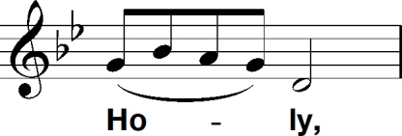

Holy,
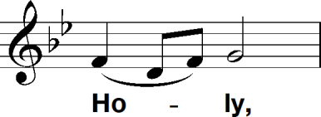

Holy Lord, God of hosts.
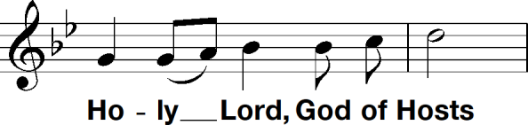

Heaven and earth are full of your glory. Hosanna in the highest.
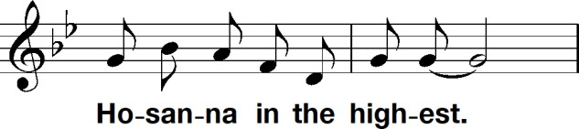

Blessed is he who comes in the name of the Lord. Hosanna in the highest.
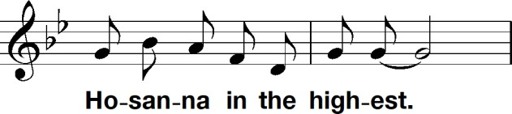

Upton Hall Responsorial Mass
Clare Hulme (b1982)

MEMORIAL ACCLAMATION Soloist: Niamh Haslam
All join in repeating each phrase after the Soloist

Save us,
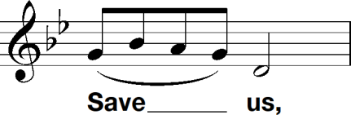

Saviour of the world,
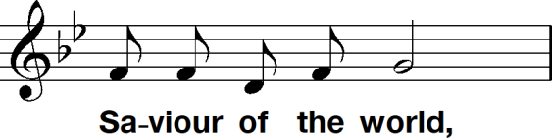

For by your cross and resurrection,
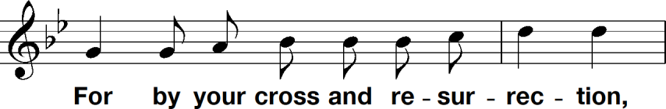

You have set us free,
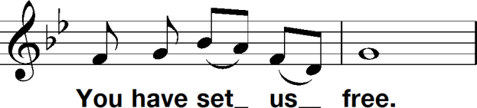

GREAT AMEN Soloist: Matilda Wootten
All join in repeating each phrase after the Soloist

Amen.
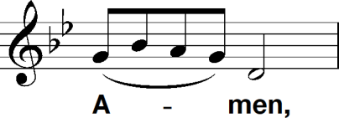

Amen.
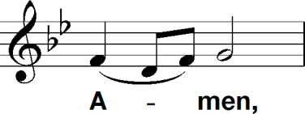

Amen.
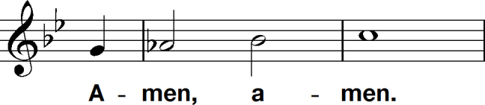

The Eucharistic Prayer concludes
Through him, and with him, and in him,
O God, almighty Father,
in the unity of the Holy Spirit,
all glory and honour is yours,

COMMUNION RITE
All stand and join together in saying the Lord’s Prayer:
Our Father who art in Heaven,
hallowed be thy name;
thy kingdom come,
thy will be done
on earth as it is in heaven.
Give us this day our daily bread,
and forgive us our trespasses,
as we forgive those who trespass
against us;
and lead us not into temptation,
but deliver us from evil
Amen.
Canon Niall Mullaley continues
Deliver us, Lord, we pray, from every evil,
graciously grant peace in our days,
that, by the help of your mercy,
we may be always free from sin
and safe from all distress,
as we await the blessed hope
and the coming of our Saviour,
Jesus Christ.

R. For the kingdom,
the power and the glory are yours now and forever.
Lord Jesus Christ,
who said to your Apostles:
Peace I leave you, my peace I give you,
look not on our sins,
but on the faith of your Church,
and graciously grant her peace and unity
in accordance with your will.
Who live and reign for ever and ever.
R. Amen.

THE SIGN OF PEACE
The peace of the Lord be with you always.
R. And with your spirit.

AGNUS DEI Soloist: Sadie Pearson
All join in repeating each phrase after the Soloist
Lamb of God,
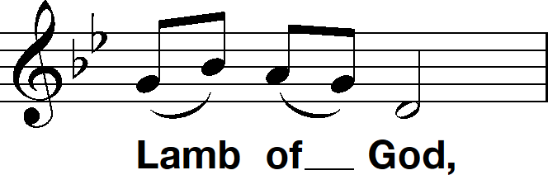

You take away the sins of the world
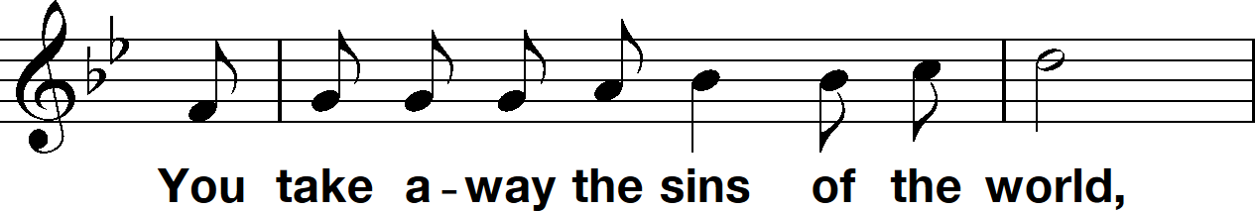

Have mercy on us
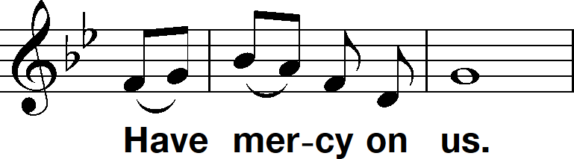

Final time
Grant us peace.
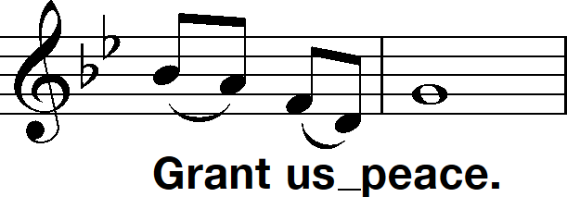

All kneel and Canon Niall Mullaley says
Behold the Lamb of God,
behold him who takes away the sins of the world.
Blessed are those called to the supper of the Lamb.
All join in saying
R. Lord, I am not worthy
that you should enter under my roof,
but only say the word
and my soul shall be healed.

COMMUNION MOTET
The Choir sings " O salutaris Hostia "

O salutaris Hostia,
Quae caeli pandis ostium:
Bella premunt hostilia,
Da robur, fer auxilium.
Uni trinoque Domino
Sit sempiterna gloria,
Qui vitam sine termino
Nobis donet in patria.
Amen.

O saving Victim, opening wide,
The gate of heaven to man below!
Our foes press on from every side;
Thine aid supply, thy strength bestow.
To Thy great name by endless praise,
Immortal Godhead, one in Three;
Oh, grant us endless length of days,
In our true native land with Thee.
Amen
André Caplet (1878 -1925)

COMMUNION HYMN
All join in singing
From Heaven, You came helpless babe
Entered our world, your glory veiled
Not to be served but to serve
And give Your life that we might live

This is our God, The Servant King
He calls us now to follow Him
To bring our lives as a daily offering
Of worship to The Servant King

There in the garden of tears
My heavy load he chose to bear
His heart with sorrow was torn
"Yet not My will but Yours", He said
(Refrain)
Come see His hands and His feet
The scars that speak of sacrifice
Hands that flung stars into space
To cruel nails surrendered
(Refrain)

So let us learn how to serve
And in our lives enthrone Him
Each other's needs to prefer
For it is Christ we're serving
(Refrain)

PRAYER AFTER COMMUNION
Lord,
we thank you for the nourishment you give us
through your holy gift.
Pour out your Spirit upon us
and in the strength of this food from heaven
keep us single-minded in your service.
We ask this in the name of Jesus the Lord.
R. Amen.

CONCLUDING RITE

The Choir sings
The Lord bless you and keep you: the Lord make his face to shine upon you and be gracious upon you. The Lord lift up the light of his countenance upon you and give you peace. Amen. John Rutter (b1945)

SOLEMN BLESSING and DISMISSAL
The Lord be with you.
R. And with your spirit.

May almighty God bless you:
the Father, and the Son, and the Holy Spirit.
R. Amen.

The Mass is ended, go forth in peace
R. Thanks be to God.

(Once Canon Niall Mullaley leaves the altar, the congregation are free to leave too).
RECESSIONAL HYMN
All join in singing
O Lord my God, when I, in awesome wonder,
Consider all the worlds Thy Hands have made;
I see the stars, I hear the rolling thunder,
Thy power throughout the universe displayed.

Then sings my soul, My Saviour God, to Thee,
How great Thou art, How great Thou art.
Then sings my soul, My Saviour God, to Thee,
How great Thou art, How great Thou art!

When through the woods and forest glades I wander,
And hear the birds sing sweetly in the trees.
When I look down, from lofty mountain grandeur
And see the brook, and feel the gentle breeze.

When Christ shall come, with shout of acclamation,
And take me home, what joy shall fill my heart.
Then I shall bow, in humble adoration,
And then proclaim: "My God, how great Thou art!"

ORGAN VOLUNTARY
We would like to take this opportunity to thank all the parents/carers and students of Upton Hall for your participation and support in today's Mass.

________________________________________________________________________
The staff and pupils of Upton Hall School would like to thank Reverend Canon Niall Mullaley for leading our celebration today and the Dean and staff of the Cathedral for their help and support in the preparation of the Mass.
________________________________________________________________________

PLEASE ENSURE THAT MOBILE TELEPHONES ARE SWITCHED OFF.
The use of private cameras, video or sound recording equipment
is strictly prohibited in the Cathedral

www.liverpoolmetrocathedral.org.uk

ACKNOWLEDGEMENTS Excerpts from the English translation of the Roman Missal (c) 2010, International Commission on English in the Liturgy, Inc. All rights reserved. Scripture texts from THE JERUSALEM BIBLE published and copyright (c) 1966, 1967 & 1968 Darton, Longman & Todd Ltd and Doubleday & Co Inc. All copyright material is used by permission. Hymn texts used by permission of CCLI.
________________________________________________________________________
PLEASE TAKE THIS ORDER OF SERVICE WITH YOU OR HAND IT TO A STEWARD AS YOU LEAVE

