Upton Hall School, FCJ
A ‘Level Drama and Theatre Studies

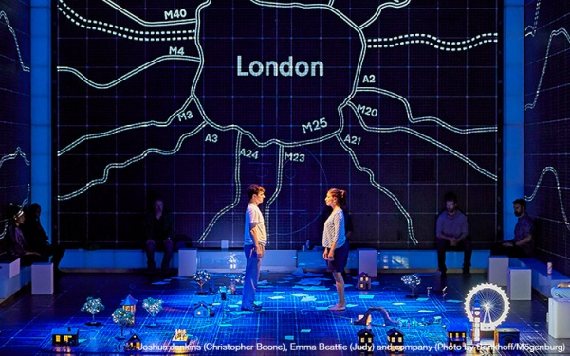

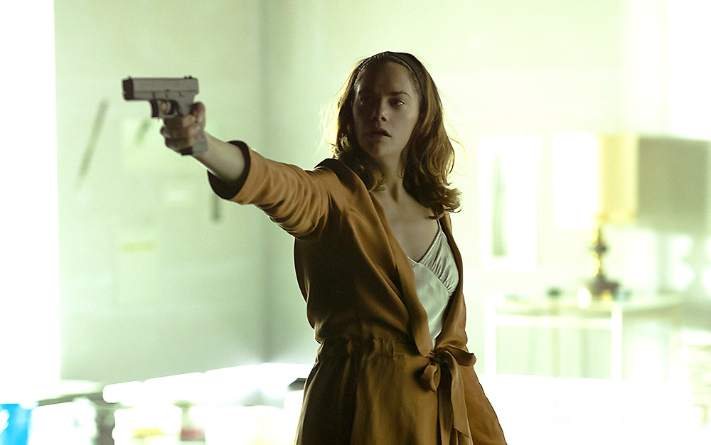
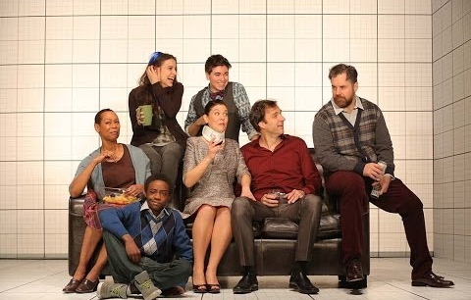

Component 3
Mock Examination Revision Pack

Mock Examination Revision Pack
November 2021
Please use the attached guidance to prepare and revise for the mock A ‘level Drama and Theatre Studies, Component 3 examination.
Component 3 Written Paper
- Your paper will last 2 hours 30 minutes (plus additional time if entitled).
- You will need blank copies of both the Section A and B texts for your examination. These will be handed out with your paper.
- You will be provided with a two-page script extract from the Section C text. This will be in your examination paper.
The Texts
Prior to the examination; re-read the plays studied and make notes on the characters, key scenes and themes.
Sections A: ‘Love and Information’ by Caryl Churchill (Post-1956 text)
Section B: ‘Hedda Gabler’ by Henrik Ibsen (Post-1956 text)
Section C: ‘The Curious Incident of the Dog in the Night-time’ by Mark Haddon/ Simon Stephens
Assessment Objectives
Each section is worth 40 Marks, giving you a total of 120 Marks to be awarded. You must answer all parts of the questions in each section.
You are assessed on the following objectives:
- AO3 – Demonstrate knowledge and understanding of how drama and theatre is developed and performed (Sections A, B and C)
- AO4 – Analyse and evaluate (their own work and) the work of others (Section B and C only)
What you need to know (Revise)
Questions will ask you about approaches to the acting, directing or design elements (set, costume, make-up or lighting) of the plays studied. In your responses you should demonstrate your full understanding of the plays studied with reference to the following:
- The text (e.g. examples of dialogue/ stage directions)
- The Style (and original staging conditions)
- Key Themes
- Plot and Structure
- Characters (Relationships)
- Historical context (The setting/ era)
- Events and social issues (When the play was written/ set)
- Political aspects (if relevant)
- Cultural elements (that impact on the play and/or your interpretation)
- Directorial approaches (Key Practitioners/ Theatre Companies)
- Live theatre you have viewed as part of the course (AO4)
Practitioners and Styles
You must know and understand and range of key practitioners/ styles and influential theatre companies.
Practitioners (Surnames) | Theatre Companies
- Stanislavski  - Brecht  - Artaud  - Rice  - Mitchell  - Grotowski  - Craig  - Lecoq  - Berkoff  - Brook  - Bausch  - Boal | - Frantic Assembly  - The Paper Birds  - National Theatre  - Kneehigh  - Wise Children  - Punch drunk  - DV8  - Gecko  - Shared Experience  - Complicite  - RSC  - Cheek by Jowl

We have studied most of the above, in class. Review your notes and identify key practitioners/ companies you might refer too.
Creative Interpretation (AO3)
Questions will ask you to discuss your creative ideas for interpreting the texts (AO3) from the point of view of an actor, director or design with reference to above and how you would intend to communicate meaning to a contemporary audience. Review and revise practical tasks explored in class, in order to inform your ideas/ responses. Have a creative interpretation in mind for each text.
For example:
- Actors will communicate characters through vocal and movement techniques, but what style will this be in?
- Designers might apply colours or textures to create mood and atmosphere, how might your chosen stage type affect this?
- Directors might apply varying ‘rehearsal techniques’ in order to communicate the style/ interpretation. Demonstrate your understanding by choosing appropriate rehearsal techniques and linking them to a practitioner.
Find key examples in your folder that you can refer to in your exam, in order to communicate your ideas for interpreting the text.

Live Theatre Influences (AO4)
In Sections B and C, you are required to refer to Live Theatre seen during the course. You must revise and refer to productions you have seen. In these answers it is essential that you can refer to:
- Venue
- Title
- Playwright
- Theatre company (if relevant)
- Names of performers
- Name of creatives (Director, Costume Designer, Lighting Designer, Set Designer)
- The Interpretation
- Actors, Acting Style and techniques
- Staging and Set Design (positioning)
- Production elements (Lighting, Sound, Costume, Hair and Make-up)
- Audience reaction

Design: Sketches/ Ground Plans/ Cue Sheets
Section C may require you to draw ground plans, costume designs and/ or draw a cue sheet for Lighting/ sound (accompanied by annotated cues on the script extract).
The most important thing to remember is that the drawings/annotations itself will only get you a few marks it is the justification of your design ideas that will get you the marks in this section. You must also refer to live theatre influences which have inspired your creative ideas.

Responding to a “quote”
Be aware, some questions may ask you to respond to a quote about theatre. This can sometimes be confusing. Make sure you read the ‘quote’ and the question carefully. Underline key words in the ‘quote’ and the question to ensure you are responding correctly.
Don’t let a ‘quote’ question throw you. Just read it carefully!

Top Tips!
- Read ALL parts of the exam paper before preparing your answers
- Know how many questions you need to answer
- Know how many marks each question gives and divide your time accordingly (you don’t have to answer the sections in order – work backwards through the paper if you want to)
- Read the questions carefully, more than once!
- Select the ones you need to answer and underline key words
- Identify what the question wants you to do e.g. discuss, explain, compare
- Re-word the question as part of your response.
- Use the P.E.E.L approach – Make a Point, provide Evidence (Quote), Clearly Explain/ justify your response, make sure you Link ideas and justifications (to the questions/ the texts)
- Use Drama terminology throughout your answers.
- Refer to live theatre you have seen (Section B and C only).

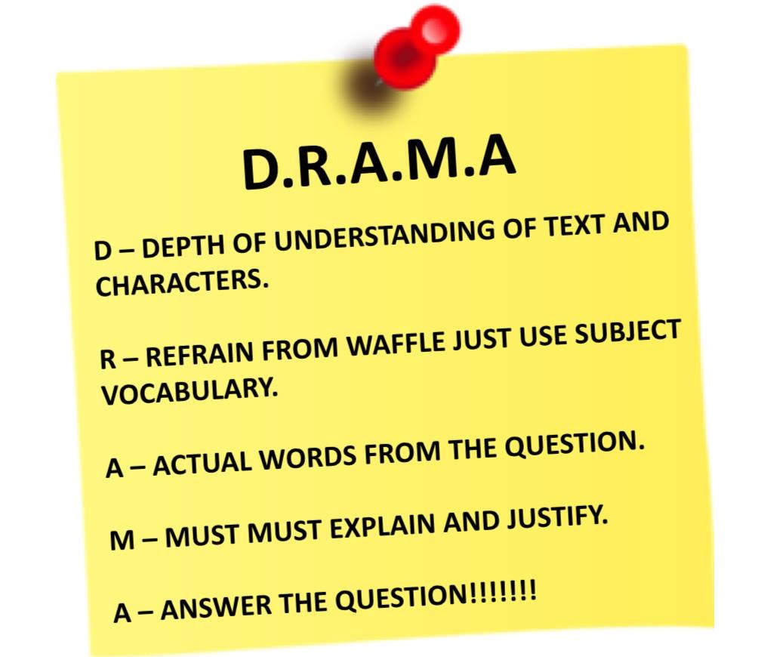

Key Terms and Definitions

Antagonist
A character in a play whose function is to oppose or block the main character (or protagonist).

Archetype
A perfect example of a certain type of character.

Atmosphere
Used interchangeably with ‘mood’ and signifying the mood or ambience of a scene.

Acoustics
The quality of the sound produced in a venue and influenced by its size and shape.

Auditorium
The space where the audience sits or stands when listening to or watching a performance.

Black box theatre
A small studio space where the ‘stage’ area is defined by black drapes or ‘black legs’.

Blocking
The precise planning of how the actors will move about the stage.

Box set
A naturalistic set, depicting a room created with three continuous walls with working doors and windows; the ‘fourth wall’ is the division between the actors and the audience.

Business
A piece of action or interplay between characters that is not scripted but added usually to create a comic effect.

Cartoon style
An exaggerated style of playing; a performance style usually found in comedies or melodrama.

Catalyst
An agent for change.

Catharsis
A purgation of emotions; in Greek tragedy, specifically the purging of pity and fear.

Chorus
A group of actors, performing in unison who mediate between the action and the audience.

Climax
The highest point of a drama after which the action falls away into the resolution.

Colour palette
In design terms a range of colours used in a production for costume and/or set.

Commedia dell’arte
A traditional Italian comic style which includes slapstick humour and stock characters that emerged in the 16th century.

Conventions
Traditional ways of doing things.

Creative adaptation
A piece of drama that is created out of an existing piece of art and/or literature.

Design concept
Usually a director’s vision of a play in production which includes all staging elements.

Design fundamentals
The basic principles behind design techniques.

Dialectical theatre
A play conducted through or based on a debate between two opposing viewpoints.

Diegetic sound
Sounds that emanate from the action on stage.

Distressed
Set or costume items that are deliberately ‘aged’ to look worn.

Ensemble
A group of performers (and/or designers), who work together on a piece of drama in the capacity of ‘equals’.

Epic theatre
Political drama; episodic in nature, aimed at communicating a message to the audience.

Expressionism
An art form which explores the world through a subjective vision with no attempt to achieve realism.

Farce
A comedic genre involving ludicrous situations which become increasingly ludicrous as the play proceeds; often includes slapstick routines.

Fourth wall
The imaginary ‘wall’ between actors and audience in proscenium arch style theatre.

Gait
The manner in which a character walks.

Genre
A particular ‘species’ of drama, for example, tragedy, comedy, farce.

Gestic acting
A performance style which embodies a social attitude.

Gobos
Metal cut-out shapes placed into a lantern to project a shape, pattern or image on stage.

Improvise
To create drama spontaneously with no reference to a script.

Lazzi
Set pieces of comic business in commedia works; often including acrobatics.

Mood
The dominant emotional tone or temper of a scene on stage.

Naturalism
A type of drama with its origins in the 19th century which presented characters as being formed by heredity or environment.

Pace
The speed at which lines are spoken or movement is made.

Pitch
Refers to the exact height and depth of a sound.

Political theatre
Drama with a political stance or message.

Promenade theatre
Where the audience follow the actors around the theatrical setting.

Proscenium arch
The arch that frames the opening between the stage and the audience.

Protagonist
The ‘first actor’ in Greek classical drama; the main character in a work of literature.

Realism
The faithful representation of life in drama and other literature.

Revolve
A large circular area of the stage that may be rotated as part of the action or to reveal new settings.

Stage directions
The playwright’s description of characters, settings or costumes as well as indication of exits and entrances and suggestions for the delivery of some lines or reactions to unfolding events.

Stage machinery
Any machinery installed to facilitate set changes or ‘flying’ of characters.

Stance
The way in which a character stands.

Stock character
A character who is immediately recognisable as a stereotype, for example, the Old Miser, the Young Lover.

Subtext
The meaning behind the lines.

Symbolism
A theatrical movement in which concrete symbols represent aspects of a character’s inner life or personality.

Theatre in the round
A theatre configuration in which the stage is surrounded by the audience with aisles to allow for entrances and exits of the actors.

Total theatre
A term applied to drama in which all facets of production and performance are included; offering a ‘total’ effect, both visual and auditory for the audience.

Transition
The moment of cross-over between one scene and another.

Transposition
A relocation in time or locale of the action of a play.

Venue
Where the piece is performed.

