English Language Mock Exam Revision List November 2021
Component 2 Section B Transactional and Persuasive Writing
In the final assessment, you will have to complete 2 compulsory writing tasks from the following possible options:
- Articles for newspapers and magazines
- Reviews – Place, Item, Cultural Experience
- Letters – Formal and Informal
- Talk
- Report
- Leaflets
However, due to interruptions to teaching this Half-Term, we have decided to set you just one task:
Write a FORMAL LETTER – LENGTH OF EXAM 30 MINUTES
You must learn the purpose, audience and format for a formal letter.
- Once you are confident about the PAF for a formal letter, the best form of revision is practising, using the exam questions set by your class teacher.
- Remember, you get 20 marks for each: 8 for SPaG, 12 for Content
Formal Letter Conventions
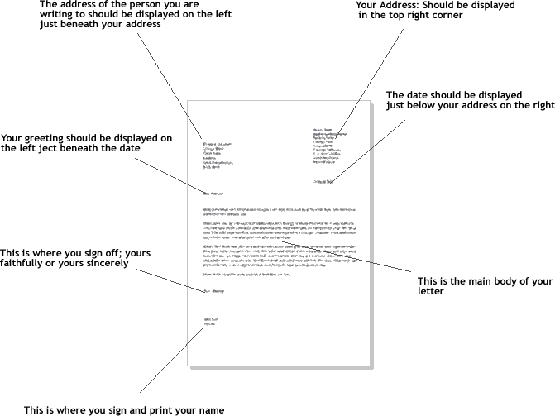

Rules for Writing Formal Letters in English
In English there are a number of conventions that should be used when writing a formal or business letter. Furthermore, try to write as simply and as clearly as possible, and not to make the letter longer than necessary. Remember not to use informal language like contractions.
Addresses:
1) Your Address
The return address should be written in the top right-hand corner of the letter.
2) The Address of the person you are writing to
The inside address should be written on the left, starting below your address.

Date:
Different people put the date on different sides of the page. You can write this on the right or the left on the line after the address you are writing to. Write the month as a word.

Salutation or greeting:
1) Dear Sir or Madam,
If you do not know the name of the person you are writing to, use this. It is always advisable to try to find out a name.
2) Dear Mr Jenkins,
If you know the name, use the title (Mr, Mrs, Miss or Ms, Dr, etc.) and the surname only. If you are writing to a woman and do not know if she uses Mrs or Miss, you can use Ms, which is for married and single women.

Ending a letter:
1) Yours faithfully
If you do not know the name of the person, end the letter this way.
2) Yours sincerely
If you know the name of the person, end the letter this way.
3) Your signature
Sign your name, then print it underneath the signature. If you think the person you are writing to might not know whether you are male of female, put you title in brackets after your name.

Content of a Formal Letter
First paragraph
The first paragraph should be short and state the purpose of the letter- to make an enquiry, complain, request something, etc.
Paragraphs 2-4
The exam board like to set a formal letter task that will ask you to give your opinion on either a topical national issue, usually to be sent to a broadsheet newspaper, or a local issue, to be sent to the local council or your MP. You might even be asked to write a letter about an issue that affects your school. This will usually be addressed to the Headteacher, governors or the school council.
- Point – give your reason
- Explain – the reason
- Develop – provide evidence in support of your point
- An example
- Facts or statistics
- A true life story
- An expert opinion
(Across the letter, try to use a variety of these methods)
I strongly advocate international travel because it broadens your awareness of the world around you.
Last Paragraph
The last paragraph of a formal letter should state what action you expect the recipient to take- to refund, send you information, print your letter, initiate changes based on your recommendations etc.
Non-fiction writing techniques:
For each text, you will also be expected to use the following non-fiction techniques to enhance the content of your letter.
DAFOREST is a useful acronym for remembering persuasive writing techniques. It stands for:

Direct address: you can directly address your audience by using the 2nd person pronoun ‘you’, through rhetorical questions [see below], or hypophora [when you ask a question and then go on to provide the answer]. This should be used sparingly though and to achieve a specific rhetorical effect.

Adjectives
The spine-chilling trailer will have you reaching a shaky hand for the popcorn. This terrifying film is a must-see. The adjectives add more flavour to the sentences, giving information about the film – it is scary – and provoking the reader’s interest by using descriptive language. You are shown the film is scary by the ‘shaky’ hand.

Alliteration
Feisty, fiercely free-spirited Fiona is not your usual damsel in distress. By repeating the same sound (not letter – ‘cat’ and ‘ceiling’ would not make alliteration), a phrase makes more of an impact on the reader and becomes more easily memorable. This is because the repetition of a sound adds rhythm to a phrase and acts almost like a hammer or a drum beat in the mind.

Facts
A short, sharp fact in a text can be effective in supporting any opinions given. It can persuade the reader to follow the writer’s thoughts on a product, event or issue. Facts are information given which is considered to be completely true. For example, Bananas contain potassium which helps your muscles contract and expand. is a good fact to use in an article about fruit being healthy.

Opinion
Using an opinion in non-fiction texts can highlight the writer’s view on the subject. For example, Bananas taste delicious in your cereal. could be used in a healthy eating article. This shows that the writer has tried fruit before and is not merely writing about facts but rather from their own experience. In this case, they are being positive about bananas.

Rhetorical Questions
These are questions asked without expecting an answer. Usually this is because the answer is simple, like ‘yes’ or ‘no’. These questions are designed to make the reader believe they have reached a decision on their own. For example: Most people would not want a second rate car with chipped paint becomes Who would want a car with chipped paint? Answer: ‘not me’. Do you want a luxury car without the luxury price tag? Answer: ‘yes’ (unless you are being difficult or have been annoyed by the article in some way).

Repetition
Restaurant Henri will set your taste buds aquiver. This restaurant will have you asking for seconds. Restaurant Henri is the restaurant of the century. Repetition aims to make the reader remember something specific by fixing it in their mind. In this case, an advert like this could aim to have the reader associate the word ‘restaurant’ with a specific place so, the next time they think about eating out, they immediately think of that place.

Emotive Language
Any language used to appeal to your emotions is emotive. For example, the dog barks helplessly, waiting for his owner to release him from the cruelly shortened lead. He waits patiently and trustingly for an owner who will never return. This kind of speak, using words like ‘helplessly’ and ‘trustingly’ are meant to make the reader feel sympathetic to the dog.

Statistics
The use of statistics to support an argument gives more information to the reader. They are important because they, as well as facts, provide the backbone to a text. Use them effectively and they will convince the reader. For example, 70% of people who eat bananas regularly are likely to lose more weight when exercising than those who do not eat fruit often.

Triplets or The Rule of Three
The rule of three can refer to two different things:
1. The repetition of something 3 times will make it stick in the reader’s thoughts. The dog saw the ball. The dog barked at the ball then the ball went flying.
2. Using 3 adjectives (or nouns) consecutively, one after the other, will make the reader remember them as a group and have more of an impact. This is also called tripling. The cave was dark, cold and dangerous.

In addition, you might want to also use the following where relevant:

Imagery
This is language which creates an image in the reader’s mind which relates to a thing or situation. The image is not literal but more of an equivalent to what the intended meaning is. I am sleepy because I have been burning the candle at both ends.

Simile
Similes compare two things by looking at a characteristic which makes them similar. This dress fits like a glove. Generally, similes use one of the following words: ‘like’ or ‘as': She was as white as a ghost.

Metaphor
A metaphor is when two things are compared using a similar characteristic. However, one thing becomes what it is being compared with. It becomes abstract because you cannot take things at face value. For example, This car is so fast, it is the cheetah of the motoring world.

Personal pronouns
(I, me, you, your, them etc.) Using these is the writer’s way of making the text appear more directly addressed to the reader. It includes the reader in the text and appeals to them. Are you familiar with our delicious cupcakes? They will have your taste buds tingling.

Discourse markers
These units of speech are used to signpost the text and draw it together. Writers use them to help the writing flow more effectively by connecting paragraphs. They can also influence the tone of the text:
Formal Examples: however, although, therefore, supposing that, in contrast, furthermore
Informal Examples: by the way, mind you, you know, anyway, so etc.

Hyperbole
This is exaggeration for reader effect: to be shocking, humorous or to play on emotions. An example is I’ve got a million things to do, It was so cold, I saw polar bears wearing jackets.
It is important that you are able to recognise these writing techniques in non-fiction texts, to be able to explain why a quote you chose is an example of that type of technique and to link them to the purpose of the text

