Upton Hall School FCJ

Uniform and Appearance – September 2022

Uniform Policy
At Upton Hall School FCJ, we believe that our uniform is essential to the ethos of our school community as it establishes a clear sense of identity, fosters a sense of inclusive belonging, and engenders both positive behaviour and self-discipline, which in turn support teaching and learning.

Pupils should wear their uniform with pride. Visitors to the school and members of the public frequently remark on how smart Upton girls look in their uniform. Pupils should continue in this tradition by keeping their uniforms smart and clean. Pupils should ensure that their shoes are comfortable as they will do much more walking than they do in Primary School and there are many more flights of stairs to negotiate every day.

If pupils do not have the correct uniform, they may be sent home to leave non uniform items at home and return in the appropriate ones. In these circumstances, they are expected to return to school immediately. All pupils are required to wear school uniform in school and when travelling to and from school.

Pupils are allowed to wear a watch. This should not be a Smart Watch. Earrings, both clear plastic and metal (in lower and upper lobes) are not permitted. Plasters covering earrings are not permitted. If ears are to be pierced, this should be at the start of a holiday so that the earrings can be removed by the time school commences. Other jewellery such as bracelets and necklaces must not be worn. Hair, if long, must be tied back neatly. If hair is to be dyed, it must be a natural colour.

Hair bands and ribbons must be either black or green. Hats or other head coverings are not permitted. Make-up and nail varnish (including fake nails) are not allowed. This includes the excessive use of fake tan. If pupils come to school in make-up, they will be asked to remove it with wipes provided. If they choose not to use the wipes or cannot remove the makeup with the wipes, they may be sent home to remove it there and are expected to return when they have done so.

Winter Uniform
AUTUMN TERM
COAT Green Blazer manufactured by David Luke (compulsory)

Plain black full-length coat for bad weather only (any manufacturer)

No other form of outer clothing is allowed

SKIRT Green Regulation knee length skirt manufactured by David Luke

BLOUSE Years 7/8 - White long-sleeved blouse to be worn with school tie (any manufacturer)

White short sleeved blouse can be worn from after Easter until October

Years 9/10/11 - Fitted white open neck blouse with short sleeves manufactured by David Luke

TIE Years 7/8 - Green/Yellow
PULLOVER Green regulation V-necked sweater manufactured by Rowlinson
CARDIGAN Green regulations V-necked cardigan manufactured by Rowlinson
SHOES Black shoes that are leather or leather look and can be polished
Heels must measure no more than 1 – 1 ½ inches

Secure fastenings are essential and shoes should not have heavy soles

Pumps are not allowed

Boots may not be worn either in school or travelling to and from school
TIGHTS Black tights can be purchased from the school shop
ANKLE SOCKS White ankle socks.
BAGS Plain black bag for books and other materials
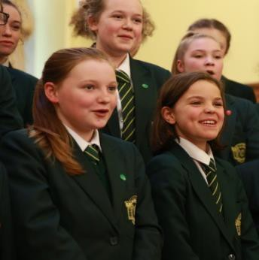

Summer Uniform – Years 7 – 11
SUMMER TERM

COAT Green Blazer manufactured by David Luke (compulsory)

Plain black full-length coat for bad weather only (any manufacturer)

No other form of outer clothing is allowed

SKIRT Green Regulation knee length skirt manufactured by David Luke
BLOUSE Fitted white open neck blouse with short sleeves manufactured by David Luke
PULLOVER Green regulation V-necked sweater in Courtelle
SHOES Black, well-polished shoes

Heels must measure no more than 1 – 1 ½ inches

Secure fastenings are essential and shoes should not have heavy soles

Boots may not be worn either in school or travelling to and from school

TIGHTS Black tights or white ankle socks.

BAGS Plain black bag for books and other materials

All items of clothing and personal belongings must be clearly marked with the owner’s name.

Compulsory PE Kit and Equipment
September 2020

Polo Manufactured by Falcon
Black/Emerald/White
Badge Embroidered in Emerald

Black Shorts Manufactured by Falcon
Badge, Embroidered in Emerald

Skort Manufactured by Falcon
Black/Emerald/White
Embroidered in Emerald

1/4 Zip top
Badge, Embroidered in Emerald

Hoody Manufactured by Falcon
Badge, Embroidered in Emerald

Black Tight Leggings Manufactured by Falcon

Black Track Trousers (optional) Manufactured by Falcon
(Name and Badge, Embroidered in Emerald)

3/4 Socks Manufactured by Falcon
Black/Emerald/White

School Kit Bag (with school badge)

One pair of PREDOMINANTLY WHITE Training Shoes
One pair of shin pads (a gum shield is advisable)

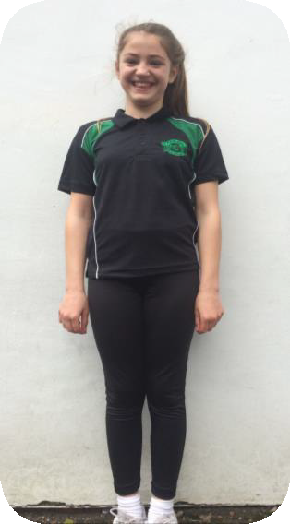
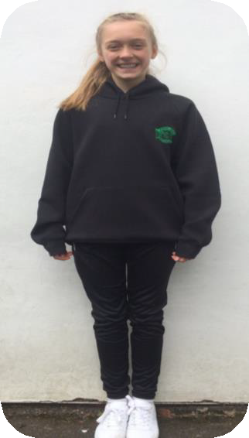
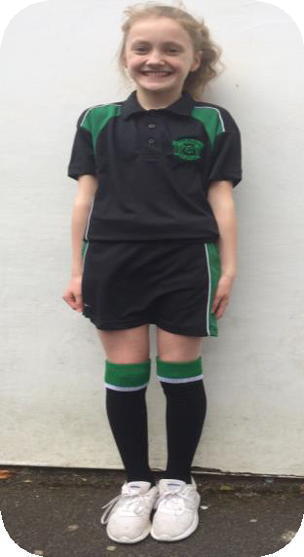
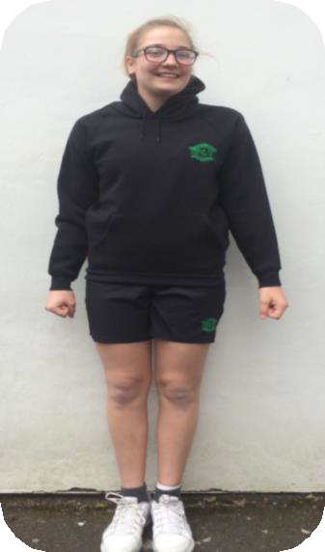
NO DARK SOLES WILL BE PERMITTED UNDER ANY CIRCUMSTANCES

Sixth Form Dress Code 2022
Members of the Sixth Form are leaders and highly valued members of the school community. As such, you set a standard which is noted by younger members of the school. Sixth Form students are expected to achieve high standards of work and commitment. Dress is an important part of creating a business-like approach to Sixth Form life. Leisure wear can create a false impression among younger students that the Sixth Form is a leisurely experience. You are therefore requested to wear a suit that would be suitable for business.

Sixth Form life is about preparing students for the future, therefore we expect students to be professionally attired.
Our Sixth Form dress code of a smart suit includes:
- A blazer/tailored jacket (black, blue, grey, cream)
- Tailored trousers or skirt (black, blue, grey)
- Smart top or shirt
- Smart shoes (please see items not permitted below)
- Sixth Form Lanyard (issued in the first half term)
- Facial jewellery is limited to earrings or one small nose stud
- Coats (outside the building only)
- Hair should be dyed natural colours

The following items are not permitted:
- Jeans
- Shorts
- Leggings
- Short skirts (over 2 inches above the knee)
- Tops with logos
- Strappy tops
- Sweatshirts/hoodies
- Trainers or white soled shoes
- Canvas shoes
- Nose rings or facial jewellery other than a small nose stud

